Year 3 | Autumn 1
Text type: Fiction
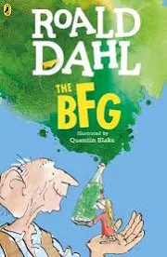
Writing purpose:
Recipe
Key Writing opportunities:
WALT 1: hook
WALT 2: identify the features of a recipe
WALT 3: create our own recipe
WALT 4: plan the method for our own recipe including time adverbials and imperative verbs
WALT 5: plan a recipe including adjectives and adverbs
WALT 6: write descriptive sentences
WALT 7: write a recipe
WALT 8: edit our writing
WALT 9: publish and create a class recipe book
Key features:
Title
Introduction
Equipment
Ingredients
Method
Time adverbials
Imperative verbs
Adjectives
Adverbs
Picture of completed dish
My writing target:
__________________________________________________________________________________________________________________________________________________________________________________________________________________

