Newall Green Primary School: History Knowledge Organiser Year Group 4 Autumn 1
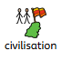
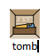

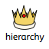
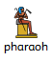
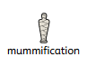
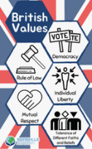
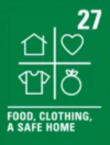
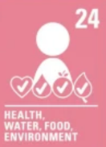
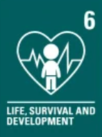
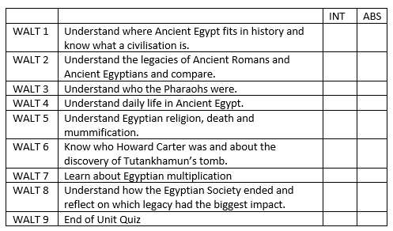
Key Vocabulary:
Government – A group of people who are responsible for making the laws and rules which people must live by in a given place.
Hierarchy – a society where people are ranked due to their status or wealth.
Mummification – the process in which a body is preserved for the afterlife.
Pharaoh – a person who was the king or queen of ancient Egypt.
Tomb - a house or burial chamber for people who died in ancient Egypt.
Civilisation - A civilization is a group of people who live together in towns or cities and have systems for farming, laws, jobs, buildings, and culture.

Key Facts:
Ancient Rome had different types of leaderships which changed throughout time, whilst the Ancient Egyptians were ruled by a pharaoh. Both civilisations had complicated hierarchies that featured slaves at the bottom.
Ancient Roman and Egyptian daily life consisted of versions of many elements we still have today, including: technology, cleanliness, entertainment, food, and houses.
Howard Carter was a famous archaeologist who discovered Tutankhamun’s tomb in the Valley of the Kings in 1922. This was a hugely significant archaeological discovery.
Egyptians believed that the pharaoh was part God, part human and they believed in lots of different gods. Some famous Pharaohs include Tutankhamun, Nefertiti and Cleopatra.
Egyptians believed in the afterlife and would mummify the dead in order for them to connect with their soul after they died.
Egyptians would use halving and doubling in order to work out multiplication problems.

Ancient Rome (Europe)
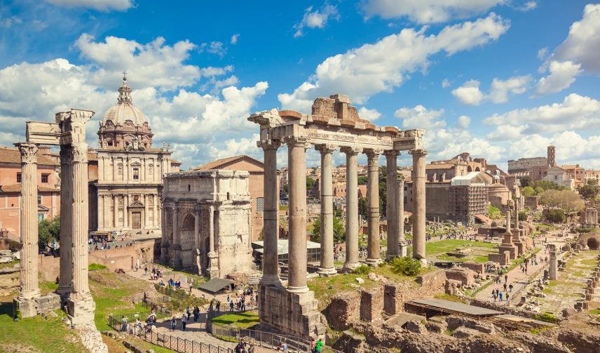
Ancient Egypt (Africa)
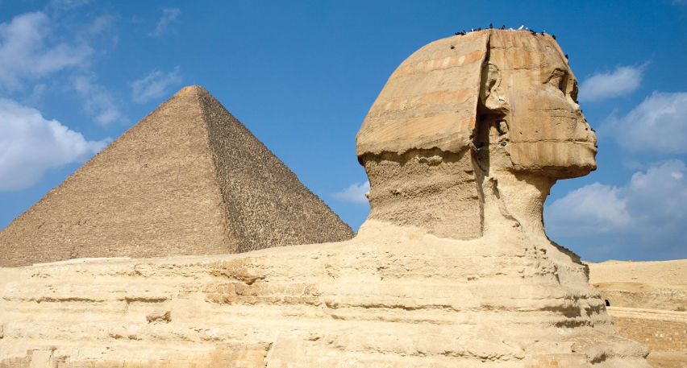

How does Ancient Egypt compare to Ancient Rome? -
A Comparison of Two Ancient Worlds
What I should already know:
I know that a country is an area of land.
I know that Italy and Egypt are both countries.
I know that people live differently in different countries.
I know that the Ancient Romans and the Ancient Egyptians lived a long time ago.

