
Artists to Study:
L.S. Lowry
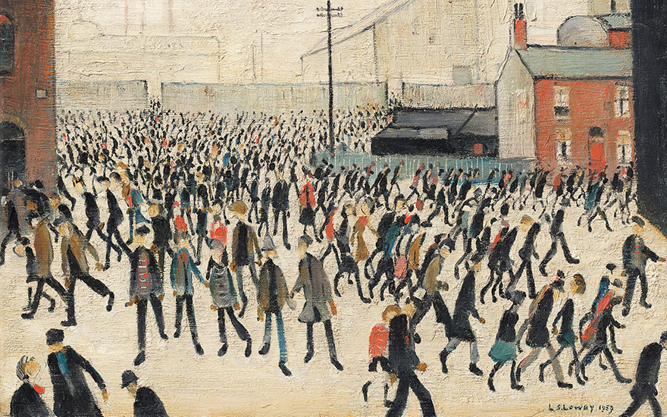
He is best known for his paintings of mills and the industrial landscapes of Manchester and Salford.

Our Lessons:
WALT 1 - draw moving people in the style of Lowry
WALT 2 - use vanishing points to create perspective
WALT 3 - understand the work of Picasso and what happened to the town of Guernica
WALT 4 - understand how emotions can be portrayed through paintings
WALT 5 - create a piece of art work showing emotion
WALT 6 - evaluate a piece of art work showing emotion

What I should already know:
- Artwork can be used to convey messages
- Colours can add warmth and coolness and can change how someone feels when viewing artwork
- How to create vanishing points linked to L.S. Lowry’s work in Y2 / Impressionism in Y6

Picasso
One of Picasso’s most famous works of art is Guernica.
Guernica is a town in Spain which was attacked by an aerial bombing from Nazi German Luftwaffe during the Spanish Civil War.
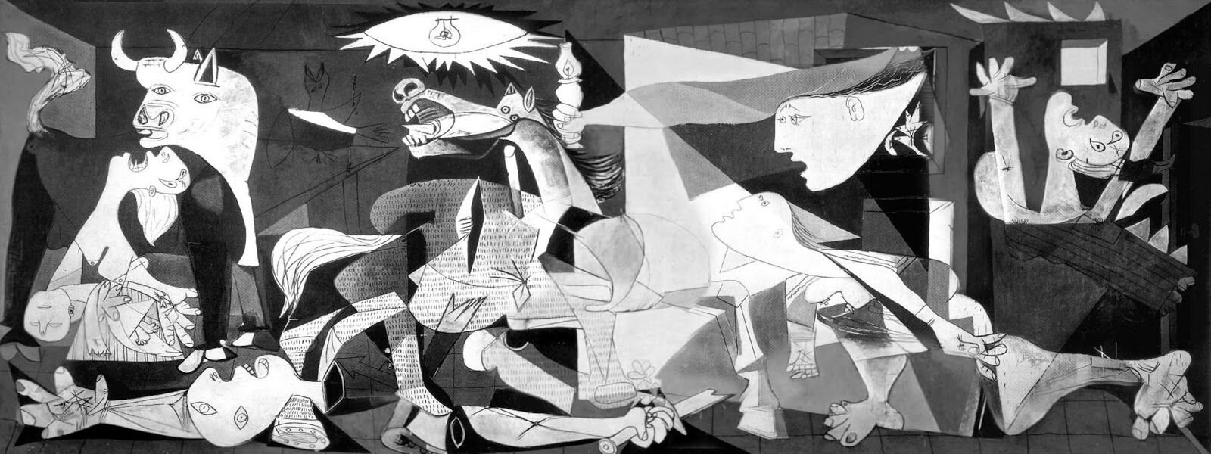

Key vocabulary:
focal point - The area in a pictorial composition to which the eye returns most naturally.
vanishing point - In perspective, the point towards which a set of lines, which are in reality parallel to each other, seem to converge.
cool colour - A colour that suggests sensations of coolness, such as blue or green.
warm colour - A colour which suggests sensations of warmness.
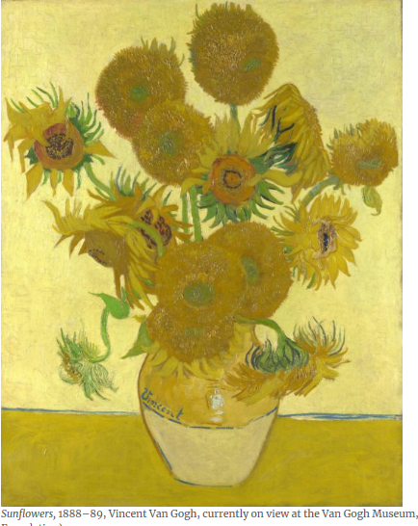
A painting like Vincent Van Gogh’s Sunflowers (1888) makes use of warm yellow and orange tones which radiate feelings of hope and joy.

