Newall Green Primary School Y6 Design and Technology Knowledge Organiser for BURGERS – Summer 2
What I should already know:
*The seasonality of British foods and when they are harvested.
*That cattle are reared by farmers.
*Some people have allergies to certain foods and they have the right to equal food options.
*Some people choose to be vegetarian or vegan and they have the right to equal food options.
*Foods provide us with different vitamins and minerals.

Key facts to retain:
Nutrition information labels help us to know what is inside the food we are eating. This can help us make choices between products and keep a check on the amount of foods we are eating that are high in fat, salt and added sugars.
You can use nutrition labels to help you eat a balanced diet. In the UK we use a traffic light labelling system to tell us whether the food has high, medium or low amounts of fats, sugars and salt.
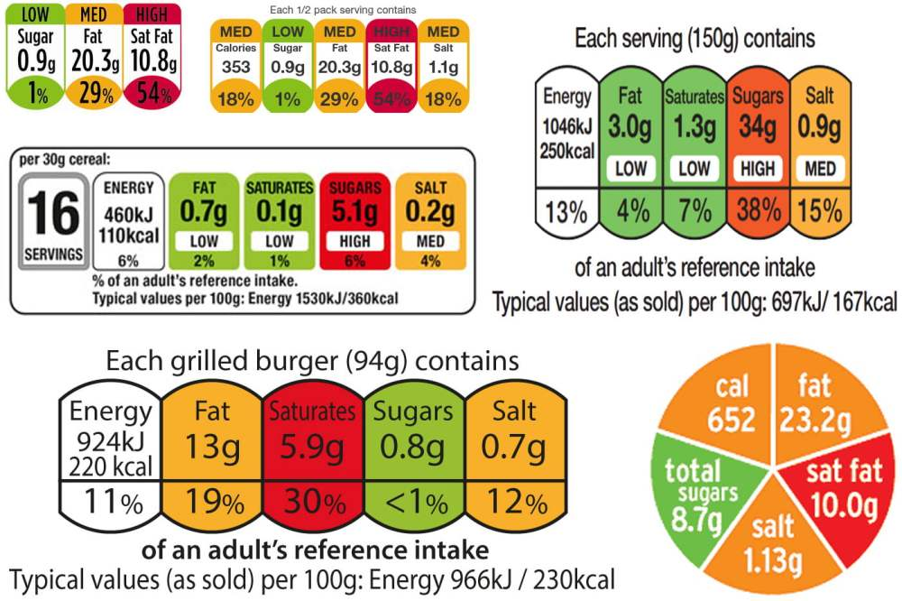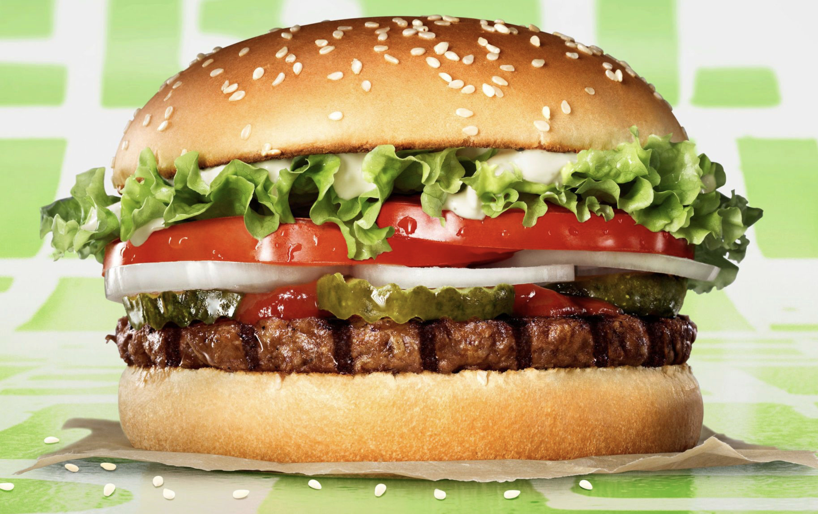
Fast food burgers are generally high in fat and sugar so can be unhealthy for you if you eat them too often.
Making burgers at home can make them a much healthier meal option. Burgers are often accompanied by:
*Bread, e.g. bread roll, sesame bun, brioche bun or bagel.
*Sauces, e.g. BBQ, tomato, tzatziki or salsa.
*Sides, e.g. chips, mac and cheese, corn, vegetables or coleslaw.
Key vocabulary:
Allergy – where your body reacts to something that is normally harmless e.g. pollen or animal fur.

Nutrition – the study of food and how it works in your body.

Calories – energy that fuels our body provided by fats, proteins and carbohydrates in our food.

Coeliac – someone with a wheat or gluten allergy.

Cuisine – a style of cooking shared by a group of people.

Patty - a small flat cake of minced or finely chopped food, especially meat.

Vegetarian – a person who does not eat meat or fish, and sometimes other animal products, especially for moral, religious, or health reasons.

Vegan - a person who does not eat any food that comes from animals and who typically does not use other animal products.
Newall Green Primary School: Knowledge Organiser Spring 2
Russian artists and the Hermitage Museum Artist Focus: Wassily Kandinski

Year group: 6
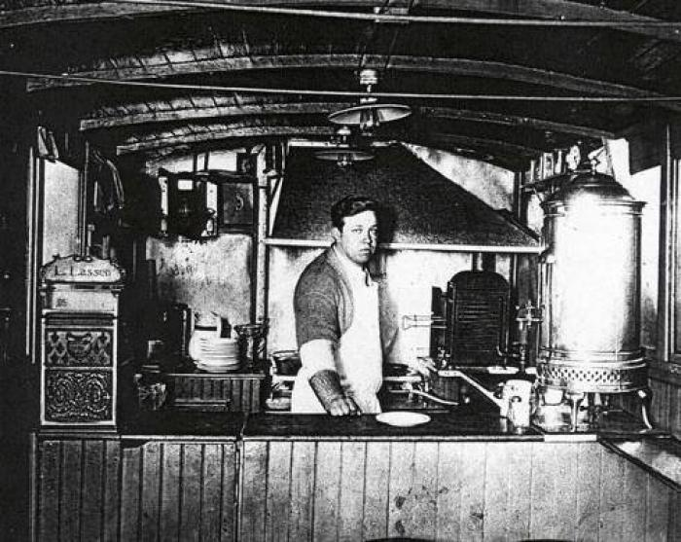
Louis Lassen (1865-1935) is credited with creating the first Hamburger in 1900.
What I should already know
ggf
Geography
Names of the Oceans
Names of the continents
Countries in Europe
What climate is
Global Warming
Ozone

