Year 5 | Summer 1
Text Type: Narrative Story
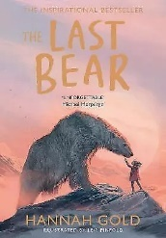
Writing purpose:
To write a narrative based around an endangered animal
Key writing opportunities:
WALT 1: Hook – Create a comic strip (DITL)
WALT 2: Complete box criteria and highlight the features of a narrative story
WALT 3: Write a detailed character description (mini write)
WALT 4: Write a detailed setting description (mini write)
WALT 5: Write in the past tense
WALT 6: Punctuate direct speech
WALT 7: Use direct speech to move the narrative on (mini write)
WALT 8: Write our opening
WALT 9: Write our build up
WALT 10: Write our dilemma
WALT 11: Write our resolution
WALT 12: Write our ending
WALT 13: Edit our endings
Key writing features:
Opening
- Expanded noun phrases
- Subordinate clauses
- Coordinating conjunctions
- Parenthesis
- Relative clauses
Build-up
Dilemma
Resolution
Ending
Past tense
Third Person
Setting Descriptions
Character Descriptions
Paragraphs around one theme
Punctuation of direct speech
My literacy targets:

