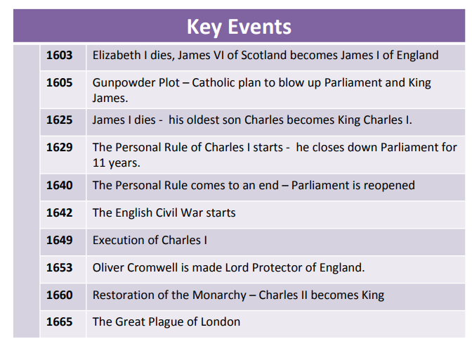

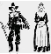
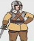
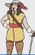







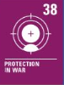





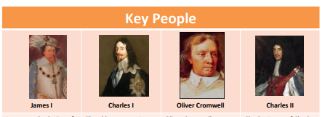
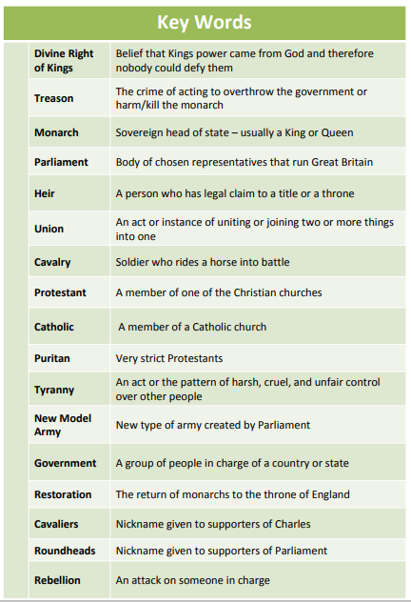
CVV
CVV
CVV
CVV
CVV
CVV
CVV
CVV
CVV
CVV
Newall Green Primary School: Knowledge Organiser
History: The Stuarts Term: Summer 2 Year group: 5 Date: June – July 2026
CVV
WALT 1: Explore the life and reign of James 1
Absent Intervention
WALT 2: Understand the Gunpowder Plot DITL
Absent Intervention
WALT 3: Understand the events of The Mayflower DITL
Absent Intervention
WALT 4: Understand why the English Civil War happened
Absent Intervention
WALT 5: Explore the battles of The English Civil War
Absent Intervention
WALT 6: Understand the events what happened after The English Civil War
Absent Intervention
END OF UNIT QUIZ
Absent Intervention

Focus: Was England right in executing the King?
What I should already know:
- Other famous monarchs e.g. Henry VIII, Queen Elizabeth I.
- Key events which have happened in History e.g. Gunpowder plot, World War II, Great Fire of London, Spanish Armada.
- Different British civilisations.
- How people lived during different historical times.

