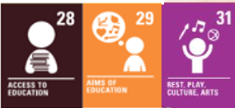
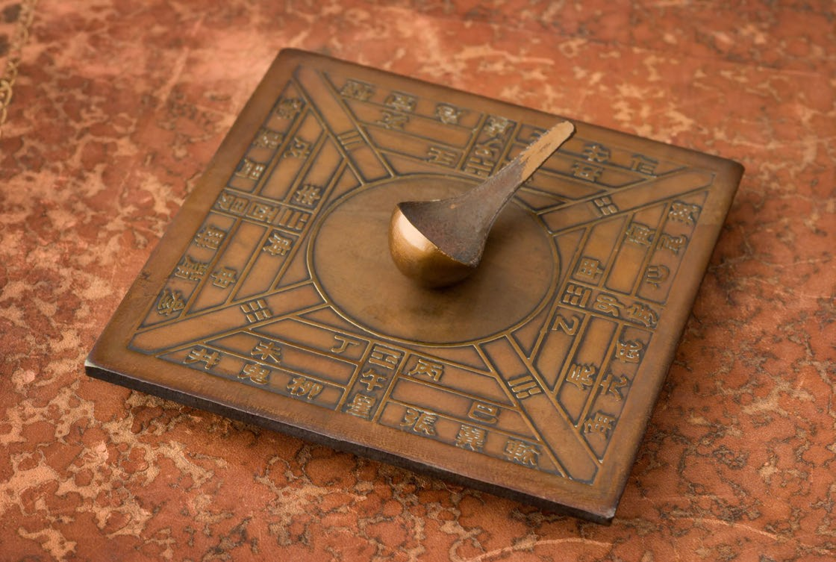


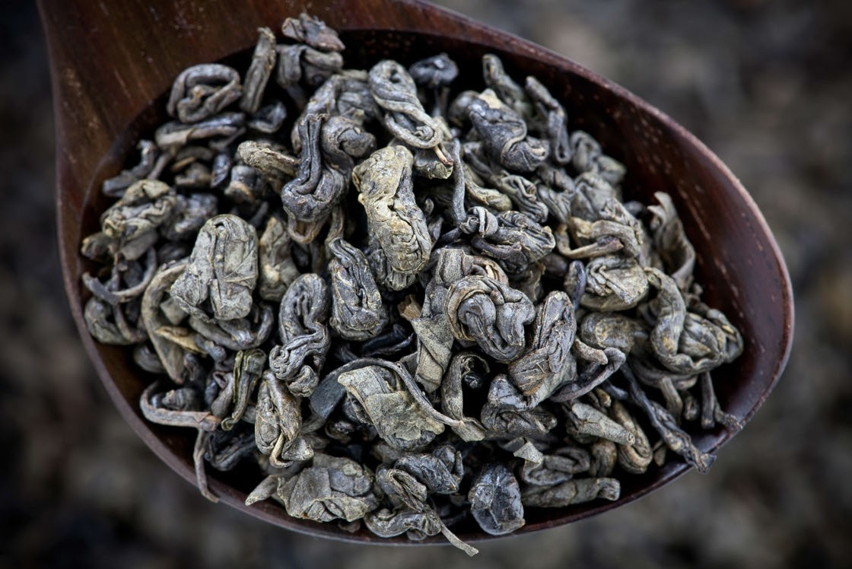


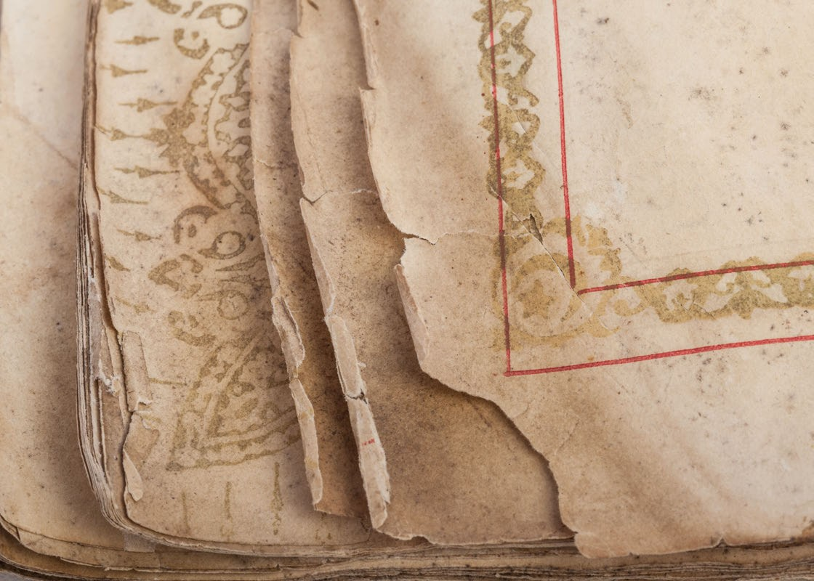


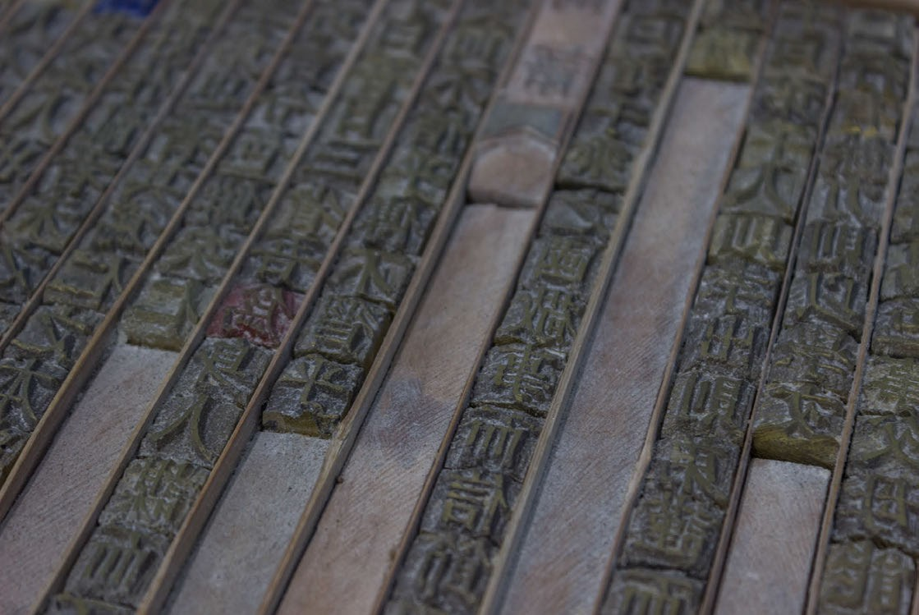


The four greatest inventions of China:

Inventor of the term:
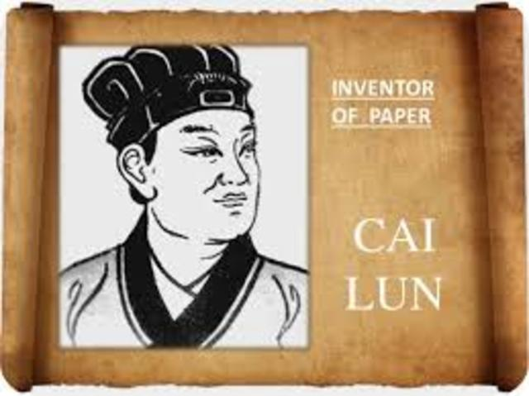

What I should already know:
- Which materials are lightweight.
- The difference between natural and synthetic materials.
- How to design, construct and evaluate a product according to given design criteria.
- How a basic gear train works.

Moveable-type printing
Paper
Compass
Gunpowder
Key facts to retain:
- The four greatest inventions of China and their uses.
- How paper is made.
- The functionality of a kite and how it works.
- The basic structure of a kite.
- How to design and draw a kite to suit a range of criteria.

Key vocabulary:
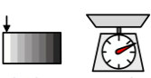Lightweight – a person or things that is lightly built or constructed.
Prototype – a first or preliminary version of a device from which other forms are developed.
Cross Spar – the horizontal frame of a kite.
Spine – the vertical frame of a kite.
Sail – helps to create air resistance to keep the kite in the air.
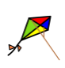Kite tails – create air resistance to balance the kite in the air.

WALT
WALT 1: build and test prototype kites
WALT 2: design a kite based on a design criterion
WALT 3: make and evaluate a kite

Focus:
Chinese inventions: prototyping, designing, and making a kite.
Newall Green Primary School:
D&T Knowledge Organiser: Big Bang Day
Term: Summer 2
Year group: 5
Date: June 2026

