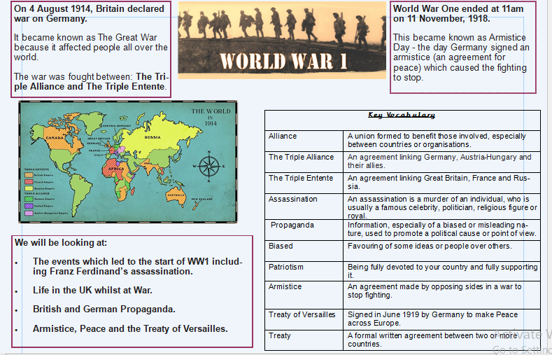

WALT 1 – re-call what we know about the First World War (Day in the life folder)
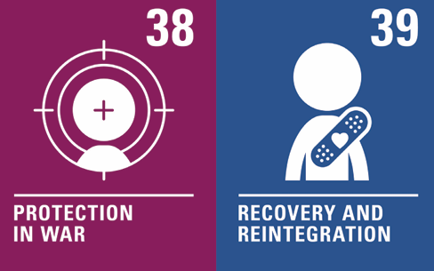
WALT 2 - know the links across the royal families of Europe
WALT 3 - understand the cause and effects of the assassination of Franz Ferdinand
WALT 4 – understand more about how WW1 started
WALT 5 – understand the use of propaganda in WW1
WALT 6 – compare British and German propaganda
WALT 7 – understand the idea of patriotism
WALT 8 - understand when, how and why WW1 ended
WALT 9 - understand and evaluate the Treaty of Versailles (Role play lesson)

WALT 1 – re-call what we know about the First World War (Day in the life folder)
WALT 2 - know the links across the royal families of Europe
WALT 3 - understand the cause and effects of the assassination of Franz Ferdinand
WALT 4 – understand more about how WW1 started
WALT 5 – understand the use of propaganda in WW1
WALT 6 – compare British and German propaganda
WALT 7 – understand the idea of patriotism
WALT 8 - understand when, how and why WW1 ended
WALT 9 - understand and evaluate the Treaty of Versailles (Role play lesson)

