WALT 1 - understand what electrical symbols represent
WALT 2 - create electrical circuits
WALT 3 - create a test to find the best insulators and conductors (Investigation)
WALT 4 - understand where different sources of electricity come from
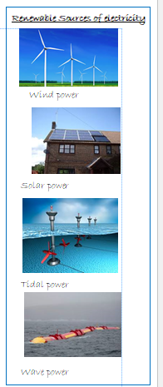
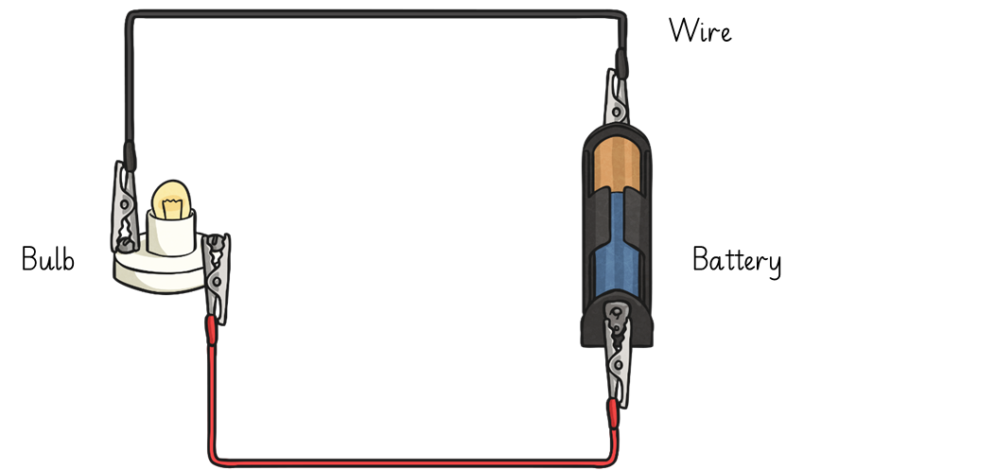

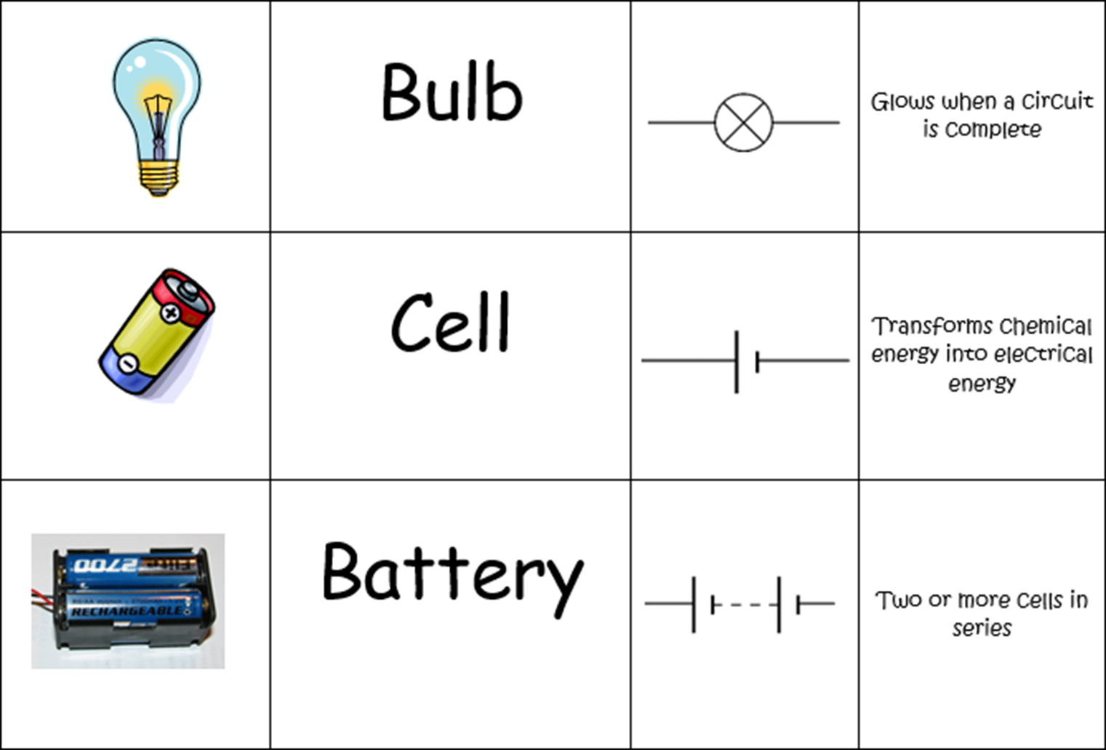
Influential People
James Joule  (1818-1889) | James Joule was an English physicist, born in Salford, near Manchester. In his time he had great contribution to the world of electricity and thermodynamics. He was best known for discovering Joule's law. Joule's first law shows the relation between heat generated by an electric current flowing through a conductor. Joule's second law says that the internal energy of an ideal gas does not change if volume and pressure change, but does change if temperature changes.
Michael Faraday(1791—1867) | Michael Faraday was one of the most famous scientists in history, and is known as the ‘Father of Electricity’. Helived about 200 years ago and is most remembered for his work on electrical energy.  At the Royal Institution he discovered the relationship between magnets and electricity. That is, if a magnet moves near a wire an electrical charge is induced.
Nikola Tesla  (1856-1943) | Nikola Tesla was a Serbian inventor, electrical engineer, mechanical engineer, and physicist. He is best known for his part in the design of the modern alternating current (AC) electricity supply system. His best-known invention was an electric motor that could run well on AC power. Tesla cars are named after Nikola Tesla because of his research on the electric motor.

