Newall Green Primary: Knowledge Organiser for RE Year Group 4 Summer 1
FOCUS: What can we learn from religions about deciding what is right and wrong?
Vocabulary
Beatitudes - the blessings listed by Jesus in the Sermon on the Mount.
Conscience- a person's moral sense of right and wrong, viewed as acting as a guide to one's behaviour.
Golden Rule - a rule that is very important to a group of religions or people.
Temptation- The desire to do something, especially something wrong or unwise.
Ten Commandments - rules of conduct given by God to Moses that some Jewish and Christians follow.

What I should already know
I know Christianity, Judaism, Muslim and Hinduism are different religions which are celebrated around the world.
I can recall stories from the Bible about Jesus.
I know what marriage and baptism is.
I know that different religions celebrate different festivals.

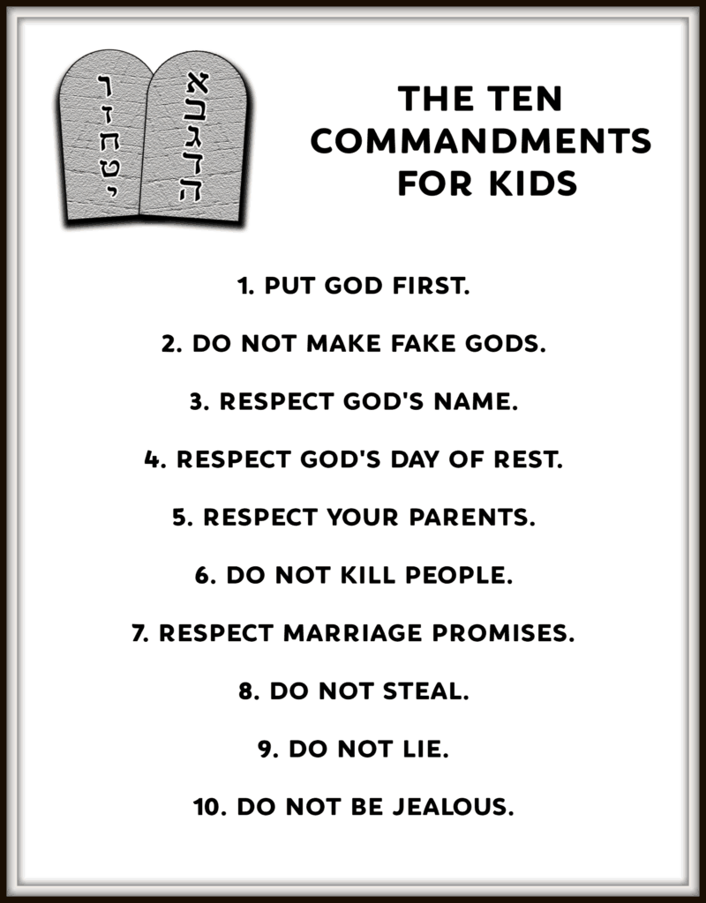





Key Facts
The Golden Rule can be found in the thinking of many different religions and groups of people.
Some Jewish people and Christians follow the ten commandments to help them live their lives.
Humanists use the Golden Rule, reason and their conscience to help them make the right choices.
Some inspirational people have been guided by their religion throughout historic events.
There are many stories in Holy books that help religious people live their lives in a good way.
WALT 1: | Obj 1: What rules are important  Obj 2: How is the golden rule important?
WALT 2:  DITL folder | Obj 3: What important messages are in the ten commandments?  Obj 4: How do they help Jewish people know how to live?
WALT 3: | Obj 5: What does Christianity say about how to live a good life?
WALT 4: | Obj 6: How do non-religious people decide what is right and wrong?
WALT 5: | Obj 7: What do religious stories tell believers about temptation?
WALT 6: | Obj 8: How have religious teachings helped to affect somebody’s actions?

