What I should already know
I know how to use a sketching pencil properly
I know how to shade and why this is effective in artwork
I understand how shadows are formed
I know what composition, proportion and perspective are in artwork

Newall Green Primary: Knowledge Organiser for Art Year Group 4 Summer 1
WALT 1: | sketch curved lines on a curved object
WALT 2: | Add depth to a curved object using shadows
WALT 3: | Use shading to show shadow and metal
WALT 4: | Understand composition in Still Life
WALT 5: | Create our own Still Life artwork
WALT 6: | Evaluate our Still Life artwork
Still Life

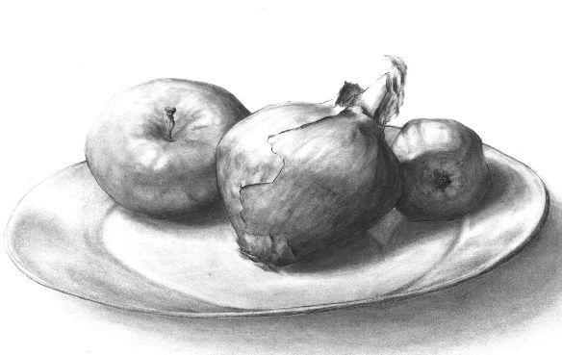
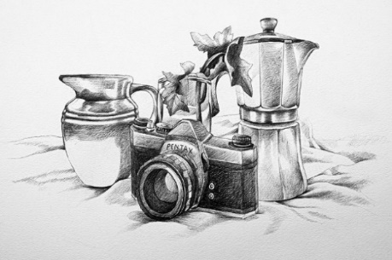
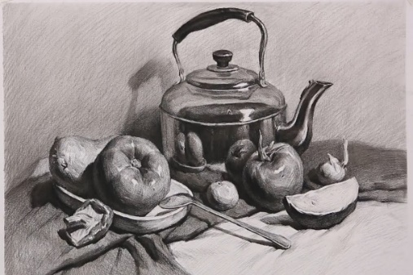
Key Knowledge
That still life is an art form depicting inanimate objects
Craftsmen like Christopher Dresser use metal as a material to create their pieces
Shading can bring a 3D object to life
Understand that shadows are formed when a light source hits an object and creates different tones and cast offs
The way you use a sketching pencil can help with curved lines and circles
Art skills
Use a sketching pencil correctly to depict curves.
Shade effectively to create shadow and tone.
The use of composition for two or more objects.
The understanding of perspective and proportion to create realistic images.
Artist Focus: Christopher Dresser

Key Vocabulary
Still Life- a painting or drawing of an arrangement of objects typically including fruit and flowers and objects contrasting with these in texture, such as bowls and glassware
Composition- the artistic arrangement of the parts of a picture
Shadow - a dark area or shape produced by a body coming between rays of light and a surface
Tone – the particular quality of brightness, deepness, or hue of a shade of colour
Materials– the matter from which a thing is or can be made from.
Perspective – the representation of 3D objects on a 2D surface to give it the right impression of height, depth and width
Proportion – the dimensions of composition between height, width and depth
Craftsman – a worker skilled in a particular craft

