Year 5 | Summer 1
Text type: Non-Chronological report
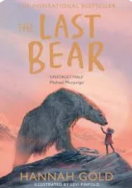
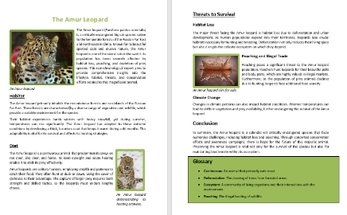

Writing purpose:
Write a non-chronological report about an endangered animal
Key Writing opportunities:
WALT 1: Hook
WALT 2: Explore non-chronological reports and complete the box criteria
WALT 3: Highlight the features of a non - chronological report.
WALT 4: Research an endangered animal
WALT 5: Use Parenthesis to add extra detail MINI WRITE
WALT 6: Plan a non-chronological report
WALT 7,8,9: Write a non-chronological report
WALT 10: Edit, up level and publish a non-chronological report
Key features:
- Expanded noun phrases
- Subordinate clauses
- Coordinating conjunctions
- Parenthesis
- Relative clauses
- Relative clauses
- Title
- Introductory paragraph
- Subheadings
- Text boxes
- Paragraphs around one theme
- Diagrams/pictures
- Captions
- Causal conjunctions
- Parenthesis
- Non-repetitive sentences
- Present Tense
- Third person
- Formal language
- Technical and subject specific vocabulary
- Glossary
- Bullet points
My writing targets:
________________________________________________________________________________________________________________________________________________________________________________________________________________________________________________________________________________________________________________________________________________________________________________________________________________________________________________

