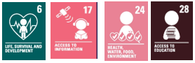
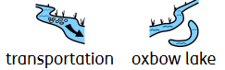
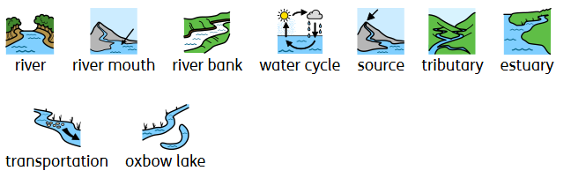
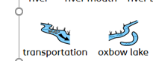
WALT 1: Understanding the Water Cycle
WALT 2: Know the parts of a river
WALT 3: Being safe in the Water
WALT 4: Understand Erosion and Deposition
WALT 5: Know what rivers are used for
Key Vocabulary:
- Meander – a curve in the river.
- Erosion - the geological process in which earthen materials are worn away and transported by natural forces such as wind or water.
- Deposition – when sediments are dropped off in a different position by the flow of the river.
- Source – the beginning of the river.
- Mouth – where the river flows into a body of water.
- Oxbow lake – a lake, or area of water, in a U –shape.
- Flood plain – low flat land along a stream which is flooded when the stream overflows.
- Tributary – when one streams meet another and they merge.
- Delta – a piece of land in the shape of a triangle made by deposits of mud or sand at the mouth of a river.
- Estuary – at the end of the river between land and the ocean.
- Transportation – when rivers pick up and transport different materials down the river.
Supporting evidence: River Trip- Venture Out (18th and 19th May 2026)
What I should already know:
- Know the names of the different rivers around the UK.
- Name the different parts of a river and understand their purpose.
- Name the animal which reside in a river.
- Understand how to identify rovers on a map.
- Understand that settlements and civilisation are often found near rivers.
- That materials from rivers are used for food, building and farming.
- The different parts of the water cycle, from evaporation to precipitation.
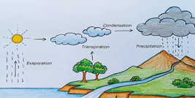

Key facts to remember:
- The different parts of the river (source, mouth, meander).
- Know that the flow of a river can cause an erosion in rock, land etc.
- Be able to name certain rivers around the UK and other parts of the world.
- To know that different rovers flow through different cities in the UK.
- Know the different processes of the water cycle.
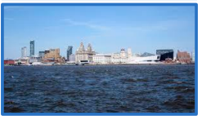
Newall Green Primary School: Knowledge organiser.
Geography: Rivers
Term: Summer 1
Year group: 5
Main Focus:
- To understand why rivers are so integral to the planet and to understand the water cycle.

