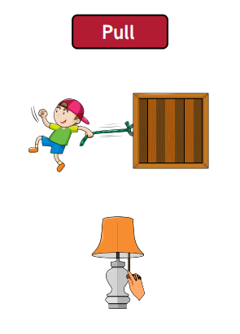
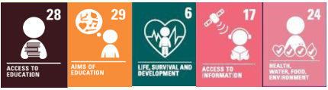
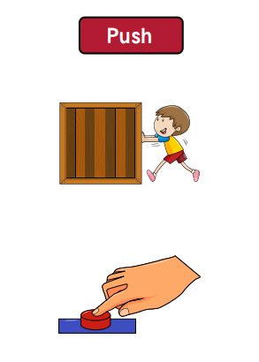
Key vocabulary:
Force 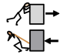 – a push or pull that acts upon an object that can cause it to move, change shape or change direction.
Contact force 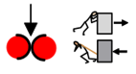 - a force that applies when two objects are touching.
Non-contact force 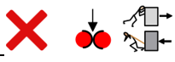 – a force that can apply even when objects aren’t touching.
Streamlined 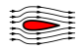 – having a form that presents very little resistance to a flow of air or water.
Attract 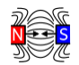 - to pull towards.
Friction 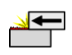 - the force that acts upon one surface when it moves against another.
Gravity 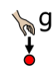 - a pull force that acts at a distance.
Pull 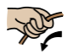 - to move something towards.
Push 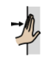 - to move something away.
Repel 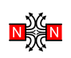 - to push away.
Resistance 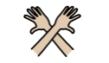 - an opposing or slowing force.

What I should already know:
- What a force is
- That a force can an objects speed, shape and direction
- Different types of forces (push, pull, magnetic,
- Some key vocabulary and understanding surrounding magnetic force

Focus: Forces in action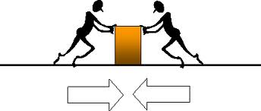
Key facts to retain:
- Gravity is a force which acts at a distance. It is a pull force that pulls objects towards the centre of the Earth.
- Friction is a force created between two surfaces when they rub together.
- Air resistance is a force that acts in the opposite direction to gravity. It acts between a moving object and the air molecules around it, slowing the object down.
- Water resistance is the force responsible for making it difficult for us to move through the water.

Newall Green Primary School:
Knowledge Organiser
Science: Forces
Term: Summer 1 and 2
Year group: 5

WALT:
WALT 1: Explain the force of gravity acting between the Earth and other objects
WALT 2: Understand the effects of frictions between two surfaces
WALT 3 Know how the surface area affects air resistance DITLF
WALT 4: To identify and explain the effects of water resistance
WALT 5: recognise that levers and pulleys allow a smaller force to have a greater effect
WALT 6: To recognise that gears allow a smaller force to have a greater effect

