`
Key vocabulary:
- Monotheistic  – relating to or characterized by the belief that there is only one God
- Polytheistic  - relating to or characterized by belief in or worship of more than one God
- God  – the creator and ruler of the universe and source of all moral authority; the supreme being
- Prophet  – An individual who is regarded as being in contact with a divine being and is said to speak on behalf of that being
- Climate change 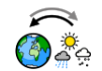 - long-term shifts in temperatures and weather patterns.
- Climate justice - the fair sharing and equal distribution of the burdens of climate change and its mitigation and responsibilities to deal with climate change.
- Plastic pollution 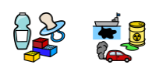- the accumulation of plastic objects and particles in the Earth's environment.
- God the creator - God's act of creation causes matter, space, time, and even the very laws which govern the universe to exist.
- Stewards or guardians - the responsibility that Christians have in maintaining and using wisely the gifts that God has bestowed.
Newall Green Primary School:
RE knowledge organiser
Term: Summer 1 and 2
Year group: 5
Focus: Green religion How and why should religion communities do more to care for the Earth?
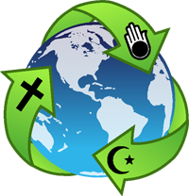
WALT 1: Does the Earth belong to God? Or to humanity? Or to every living thing?
WALT 2: What do Muslims think and do about caring for the earth and working to improve the environment?
WALT 3: What do Christians think and do about caring for the earth and working to improve the environment?
WALT 4: What do Hindu people think and do about caring for the earth and working to improve the environment?
WALT 5: What do Jewish people think and do about caring for the earth and working to improve the environment?
WALT 6: What do non-religious people think and do about caring for the earth and working to improve the environment?
WALT 7: Can I express my own views on caring for the Earth and decide on what ways we can make change? DITLF
WALT 8: Quiz
Key facts to retain:
- Make connections between beliefs about the earth and activist behaviour in different religions.
- Understand the challenges facing the planet and responses from different religions.
- Discuss and describe our own and others’ ideas about the kinds of collaboration, activism and commitment needed to ‘save the Earth’.
What I should already know:
- Have a basic understanding of environmental problems such as plastic pollution, global warming and climate change.
- Some religious and non-religious people believe our actions when we are alive will positively/negatively impact what happens to us when we die
- In Christianity, Islam and many other faiths, most believe that God has always existed as judge over his creation, Earth.
- Have a basic understanding of Key religions Holy Books. For example, The Bible and Quran.

