We will be reading The Very Hungry Caterpillar, The Very Busy Spider, Butterfly Bouquet, Snail Trail and A Good Place.
In literacy we would like your child to be able to:
- Recognise their own name
- Write some of the letters in their name
- Point to the writing in a book.
Nursery Spring 2
Knowledge Organiser
We will be looking at life cycles, we will watch caterpillars form cocoons and hatch into butterflies. We will plant seeds to grow a butterfly garden.

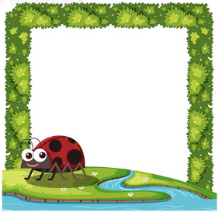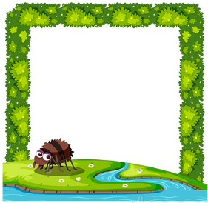
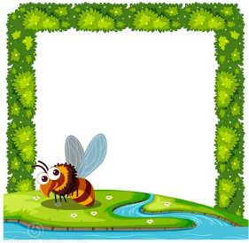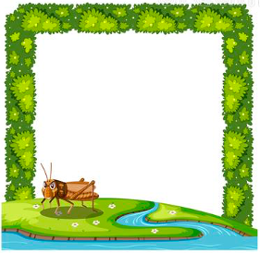

Knowledge Organiser – Insects and Minibeasts
Insects and minibeasts
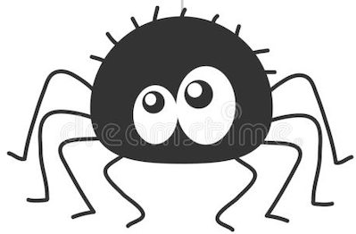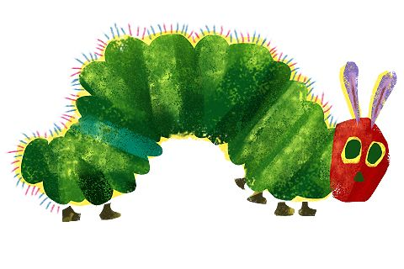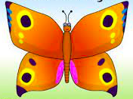

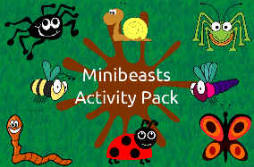
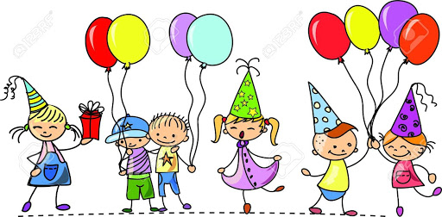
We are learning about rhyming, What is rhyming? Which words rhyme? How do you know?

We will also be reading rhyming stories such as:

‘Chicken Licken’.

In Phonics we would like your child to be able to:
- Continue a rhyming
string e.g. tin, pin,
bin, fin…

In maths we would like your child to be able to:
- Count numbers in order to 10, 15 or beyond
  - Recognises numerals 1 to 10 and beyond
  - Make marks on paper that look more like numbers
  - Use fingers to show a number
  - Match a numeral to an amount of objects
Maths-
- Recognise numeral 1-10 and representing numbers and amounts
- Show interest in problem solving
- Matches quantity to amounts.

Key Vocabulary-
Minibeast change life cycle insects outdoors growing

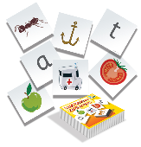
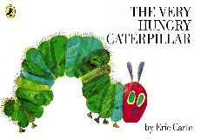
Phonics-
- Hear and says the initial sounds in words.
We are focusing on the following letter sounds:
i n d m

The topic this term will be all about Minibeast
Literacy-
- Joins in with repeated refrains.
- Thinks about key events in a story.
- Begins to be aware of the way stories are structured.
- Describes the main story setting and important characters.
