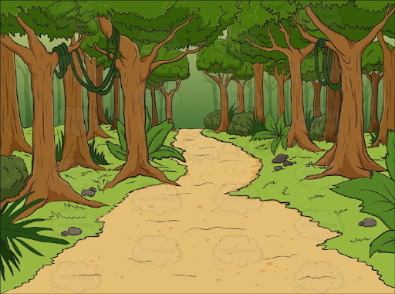
Nursery Spring 1 Knowledge Organiser
Traditional Tales

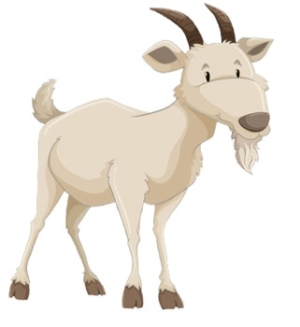
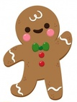
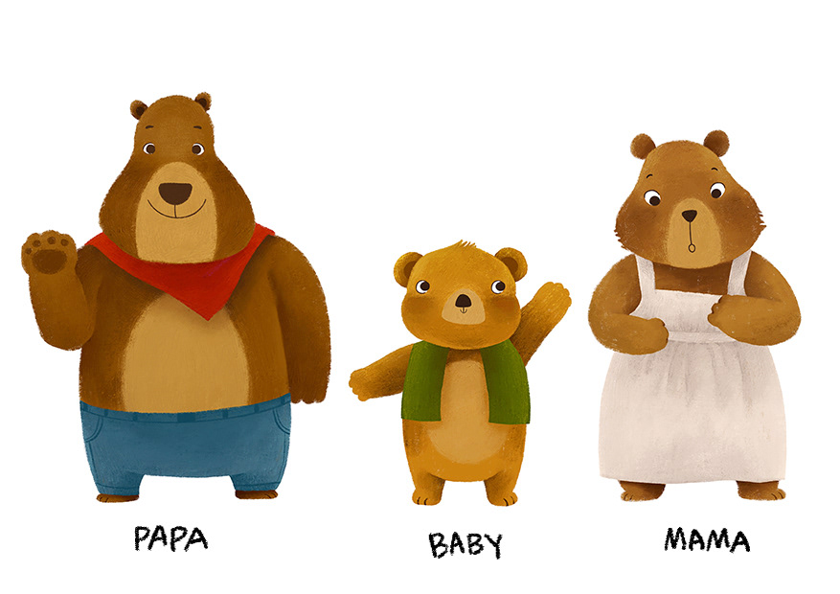
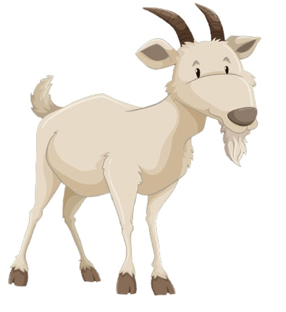
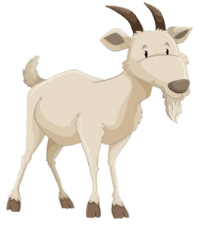
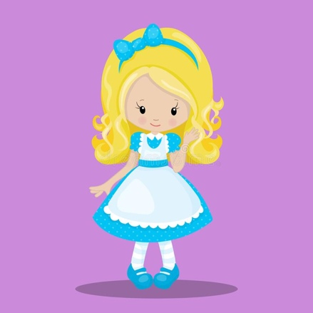
In Literacy ………
We will be doing lots of mark-making with purpose for example writing our name and becoming more confident towards holding a pencil in one hand a tripod grasp

We are learning to look at the illustrations and make predictions to help us find out about the characters and events in a story

In Maths ……….
We will continue working on recognising numerals that we see all around us eg on buses, house numbers etc.

We will also be learning to use postitional language to describe where an object is eg on top of, under, next to, between, behind.

We will begin to look at repeating patterns and try to continue and make our own AB repeating patterns.
In Phonics ……….
We are learning to listen for the initial sound in words and be able to say those sounds and suggest other words beginning with the same sound.

Books for the term:

Little Red Riding Hood
Goldilocks and the Three Bears
Jack and the Beanstalk
The Gingerbread Man
The Three Little Pigs

Key words for our topic:
positional language traditional predict rhyme illustration

