States of Matter

Key Vocabulary
States of matter – materials can be one of three states: solids, liquids or gases. Some materials can change from one state to another and back again.
Solids – these are materials that keep their shape unless a force is applied to them. They can be hard, soft or squashy. Solids take up the same amount of space no matter what has happened to them.
Liquids – take the shape of their container. They can change shape but do not change the amount of space they take up. They can flow or be poured.
Gases – can spread out to completely fill the container or room they are in. They do not have any fixed shape but they do have a mass.
Water Vapour – this is water that takes the form of a gas. When water is boiled, it evaporates into a water vapour.
Melt – this is when a solid changes to a liquid.
Freeze – liquid turns to a solid during the freezing process.
Evaporate – turn a liquid into a gas.
Condense – turn a gas into a liquid.

Newall Green Primary: Knowledge Organiser for Science (States of Matter) Year Group 4 Spring 2
What I should already know
ggf
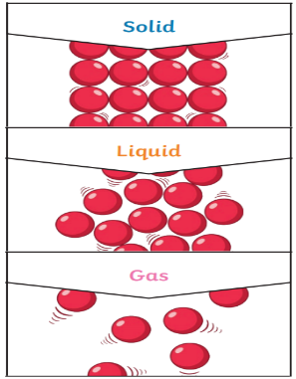
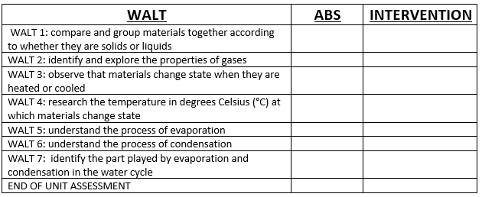
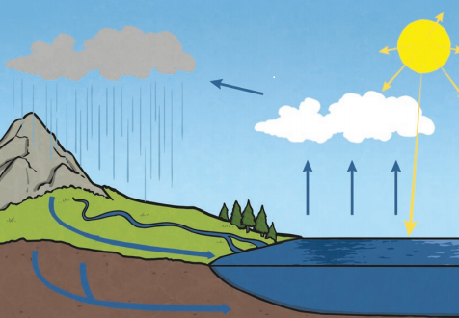

I know that solids are generally hard materials.
I know that running water from a tap is a liquid.
I know that gases are often more difficult to see.
I know that the temperature of something tells us how hot or cold it is.
I know that it rains in the water cycle.

Key Knowledge
Materials can be grouped together according to whether they are solids, liquids or gases.
Particles in a solid are close together and cannot move. They can only vibrate.
Particles in liquid are close together but can move around each other easily.
Particles in a gas spread out and can move around very quickly in all directions.
When water and other liquids reach a certain temperature, they change state into a solid or a gas. The temperature that these changes happen at are called the boiling, melting or freezing point.
Evaporation occurs when water turns into water vapour. This happens very quickly when the water is hot, like in a kettle, but it can also happen slowly, like a puddle evaporating in the warm air.
Condensation is when water vapour is cooled down and turns into water. The water vapour in the air cools when it touches a cold surface.
Condensation and evaporation occur in the water cycle.

