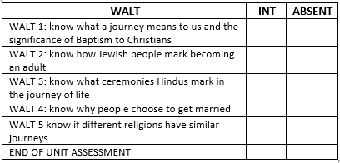
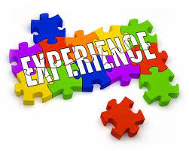
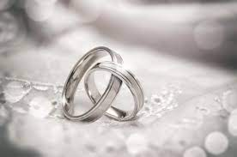
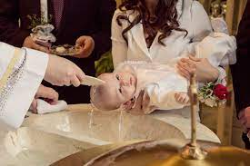
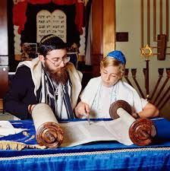
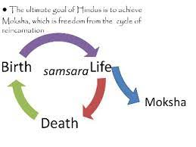

I know Christianity, Judaism and Hinduism are different religions which are celebrated around the world.
I can recall stories from the Bible about Jesus.
I know what marriage and baptism is.
I know that different religions celebrate different festivals.
Vocabulary
Life Journey- what happens along the way, from moment to moment.
Baptism- An initiation ceremony and admission into Christianity.
Bar and bat mitzvah- A bar mitzvah (masc.) or bat mitzvah (fem.) is a coming-of-age ritual in Judaism.
The Vedas- Hindu Holy texts.
Moksha- liberation from the cycle of death and rebirth (samsara)
Dharma- Hindu concept of moral righteousness.
A ketubah -a Jewish marriage contract.
Vows- A promise.
Wedding- A marriage ceremony

Key Facts
Different religions share similar mile stones in life journeys.
Baptism is an initiation ceremony within the Christian church which can be take place as an infant baptism, confirmation, or believers’ baptism.
Bar/Bat Mitzvah mark the move for Jewish young people from childhood towards adulthood. Young Jewish people are then responsible for their own actions.
Religious and non-religious people choose to get married for a variety of reasons.
Jewish and Christian beliefs describe life as a journey based on a linear view of time- from here to judgement and beyond.
Hindu beliefs take a cyclical view on the journey of life- reincarnation on the wheel of life, death and rebirth until escaping to Moksha.

Why do some people think that life is a journey?
What significant experiences mark this?

Newall Green Primary: Knowledge Organiser for RE Year Group 4 Spring 2

What I should already know
ggf

