Key Vocabulary
Tapestry- a piece of thick textile fabric with pictures or designs formed by weaving coloured weft threads or by embroidering on canvas, used as a wall hanging or soft furnishing.
Illuminated Letters- usually. the first letter of a page or paragraph. It was always enlarged and in colour.
Designs - a plan or drawing produced to show the look, function, or workings of an object before it is made.
Replicate – to reproduce or make an exact copy of something.
Materials – the matter from which a thing is or can be made from.
Mediums – the materials an artist uses, as well the type of support, or surface, used for painting.
Dragon heads – one of the most famous symbols of the Vikings found on the bow of a longboat.
Long boat - long and narrow boats which the Vikings used to travel quickly through water.
Composition-

Newall Green Primary: Knowledge Organiser for Art Year Group 4 Spring 2
Viking Art
What I should already know
ggf
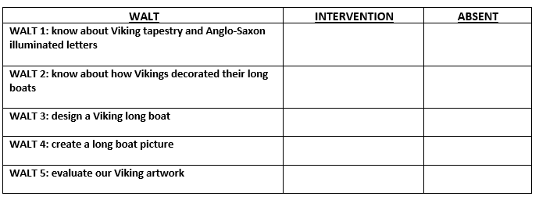
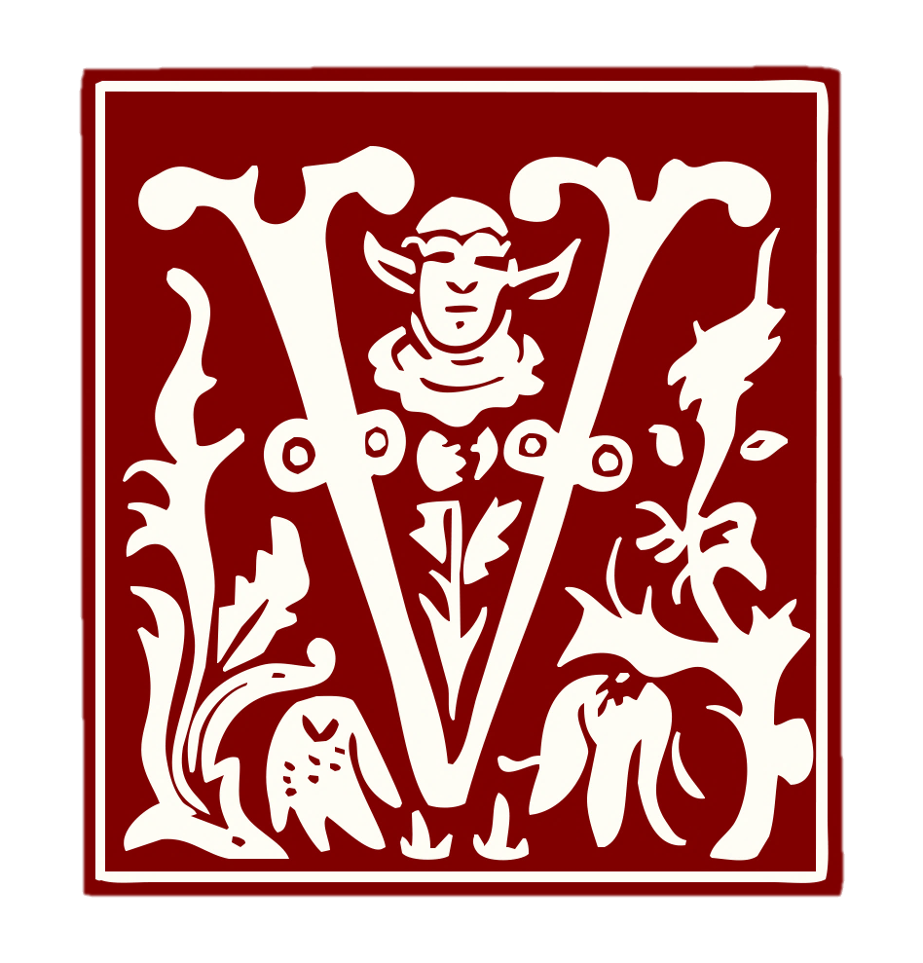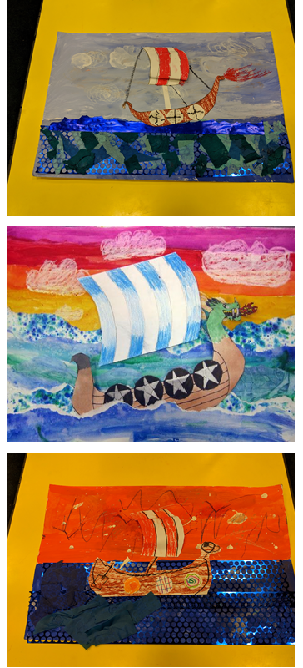

I know the Vikings invaded Britain.
I know the Vikings travelled from Scandinavian countries.
I know the Vikings travelled by boat.
I know what perspective, composition and horizon lines are in artwork.

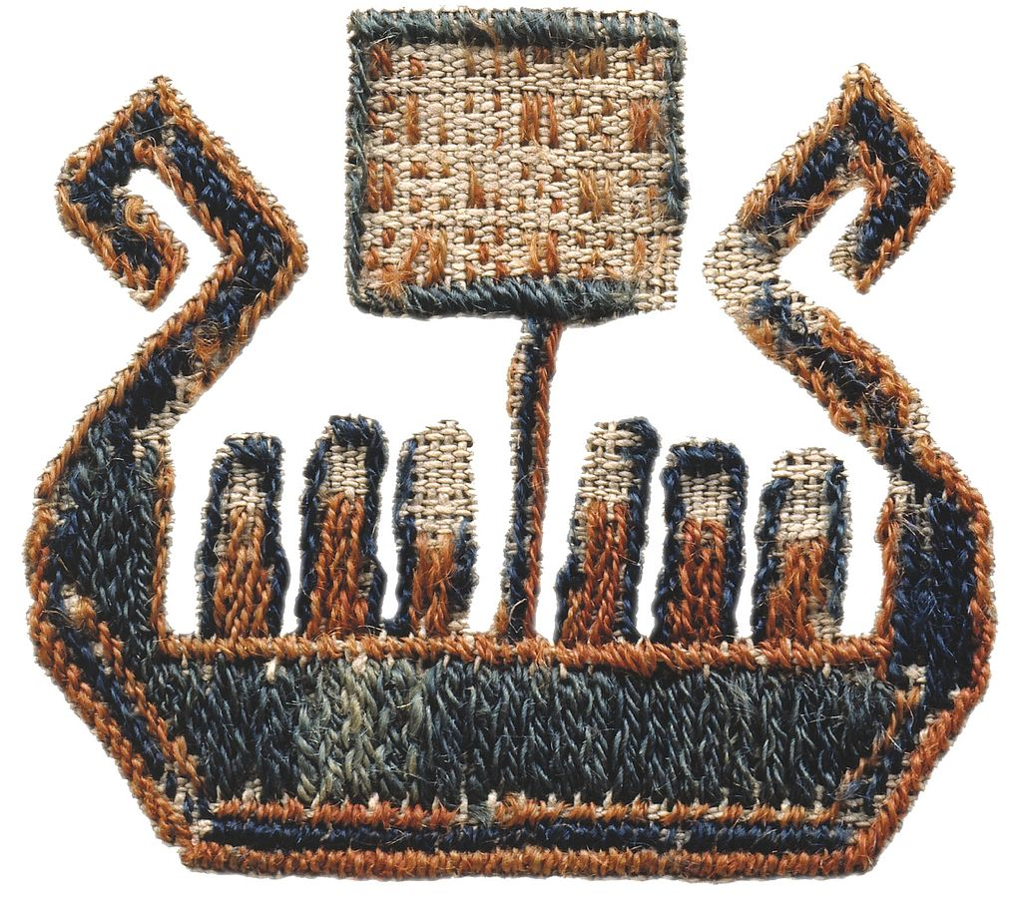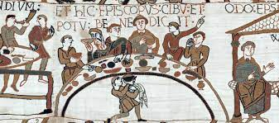
Key Knowledge
Viking Art is also commonly known as ‘Norse Art’
The Överhogdal tapestries are a group of extraordinarily well-preserved textiles dating from late Viking Age.
An illuminated letter was usually the first letter of a page or paragraph. The Anglo-Saxons created their own distinctive style of illuminated lettering by borrowing styles of different countries.
There are 6 recognised styles of Viking art.
Long boats were used by Vikings to travel.
Dragon heads would be seen on the prow of a Viking long boat.
Viking boats were sometimes known as dragon ships.
Art skills
Blend colours to form a background.
The importance of correct proportions when sketching the outline of a shape.
The use of composition, perspective and horizon line.
Selecting appropriate materials and mediums.

