The
What I should already know:
Religious people follow specific teachings on how to live their lives.
Humanists believe that we only have one life and that we should do good things from our own motivation.
That racism has no place in our world.
That racism has huge impacts on people’s lives.
Key Vocabulary
racism | When people think that one colour or race is better than another, and they treat or mistreat people based on that belief.
Anti-racist | A person who opposes racism and promotes racial equality.
fairness | The quality of treating people equally or in a way that is right or reasonable
justice | When people behave in a way that is fair, equal and balanced for everyone.
scripture | The sacred/special writings of a religion.
prejudice | An unfair and unreasonable opinion or feeling formed without enough thought or knowledge.
inclusion | The act or practice of including and accommodating people who have historically been excluded (because of their race, gender, sexuality, or ability)
diversity | Including people from a range of different social and ethnic backgrounds and of different genders, sexual orientations, etc.

A quote from Hindu Scripture:
I look upon all creatures equally; none are less dear to me and none more dear."

Hany El-Banna
Co-founder of Islamic Relief which is an international Muslim relief charity.
Laura Marks
Founder of Mitzvah Day, which encourages people of different faiths to come together to engage with local charities.
Key facts to retain:
Racism is an example of unfairness. It is about people’s lives being made worse just because of their race, the colour of their skin or their ethnic group.
Religious holy books speak about treating others with goodness and fairness.
Humanists speak about living good lives for our own and our communities’ benefit.
Many religions and worldviews have examples in their scriptures, history and tradition of those who have made a courageous stand for justice, equality and fairness. Below are some of those people:
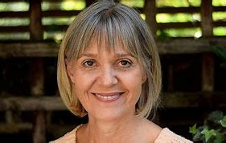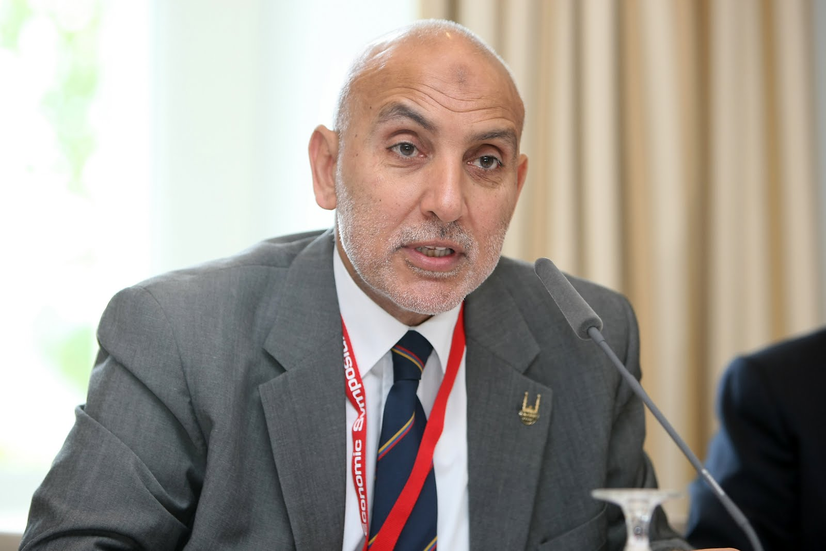

Knowledge Organiser for RE What can be done to reduce racism? Can religion help? Year Group: 6 Spring 2

