Newall Green Primary School: Knowledge Organiser Spring 2
Russian artists and the Hermitage Museum Artist Focus: Wassily Kandinski

Year group: 6
Key vocabulary:
Abstract art - a combination of colours, lines, and shapes that are not meant to be realistic.

Fauvist - the name of a modern art movement in the early 20th century which was influenced by bright colours.
Cubism - a style of art which aims to show all of the possible viewpoints of a person or an object all at once. It is called Cubism because the items represented in the artworks look like they are made out of cubes and other geometrical shapes.
Expressionism - Expressionist artists try to express a feeling with what they create. Colours and shapes are not used in a way people see them, but as the artist feels them
Warm colour - a colour which suggests sensations of warmness, such as red or yellow. Warm colours tend to project from the picture plane.

Cool colour - a colour that suggests sensations of coolness, such as blue or its associated hues, blue-green, and blue-violet. Cool colours appear to recede from the picture plane and therefore suggest depth.

Plane - a flat surface; any distinct flat surface within a painting or sculpture can be referred to as a plane.

Key facts to retain:
The State Hermitage Museum is a museum of art and culture in Saint Petersburg, Russia. It is the second-largest art museum in the world.
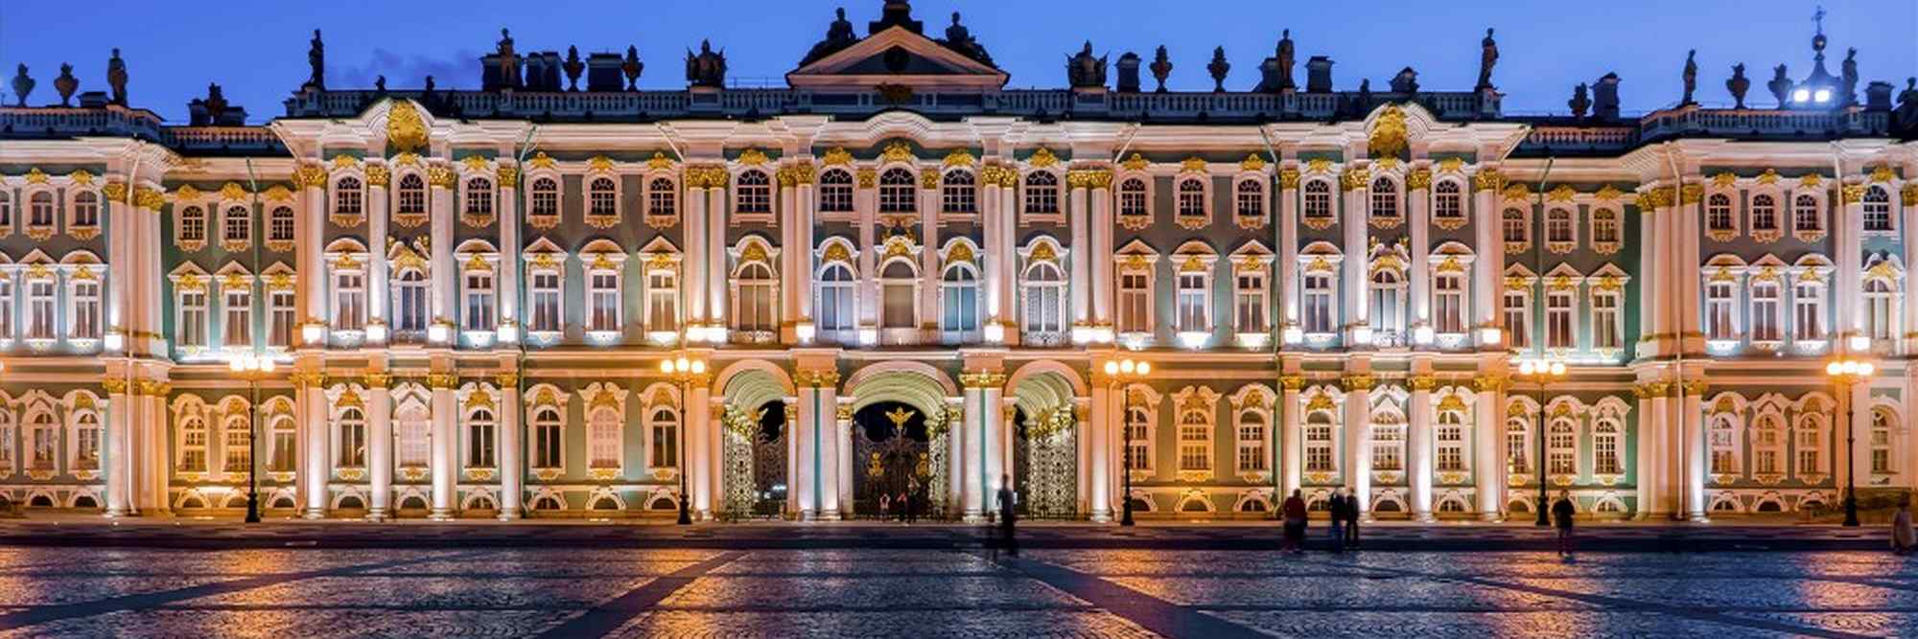
Wassily Kandinsky (1866 - 1944)
Wassily Kandinsky was a Russian painter. Many people think he was the first abstract artist. He was the first painter to stop painting pictures of things and instead paint just using colours and shapes. He believed that this let him paint honestly about his feelings. A lot of other painters learned a lot from Kandinsky’s ideas.
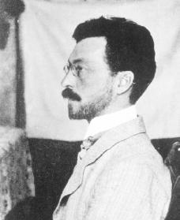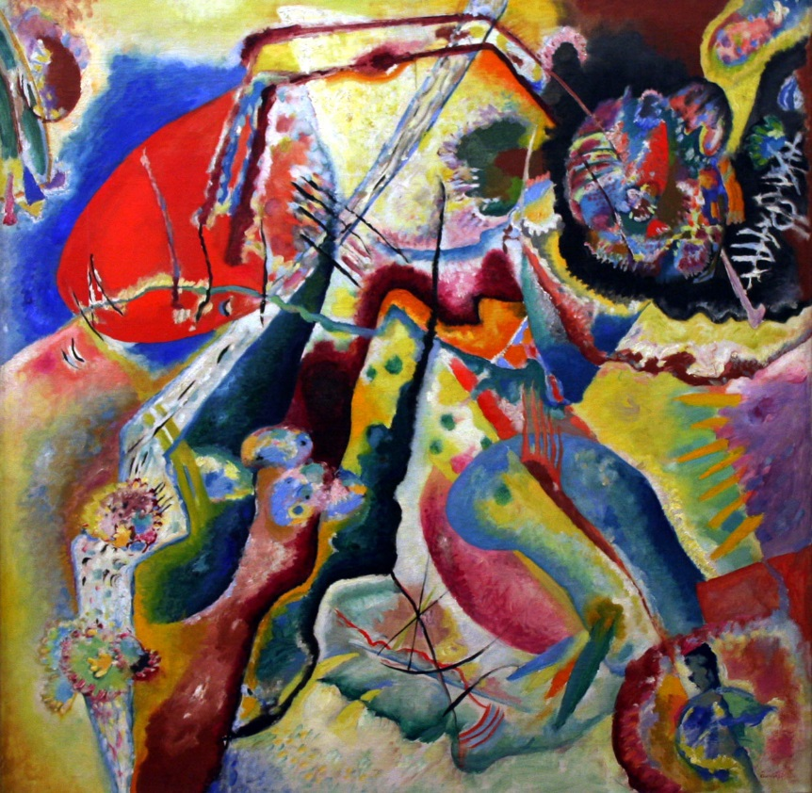
Marc Chagall (1887 – 1985)
He was a Jewish, Russian-French artist. He is famous for his fauvist, cubist and expressionist paintings.

This is the piece of music that gave Kandinsky an unusual visual response and made Kandinsky give up his law career to study painting. Often, Kandinsky would listen to music while he painted and try to paint what he heard.
What I should already know:
- How to hold a pencil
- The name of some famous artists
- Some artistic vocabulary
- The names of the primary and secondary colours
- The different tools and equipment to use to create different effects.
- The names of different media (paint, charcoal etc)
- How to achieve different brush strokes.

