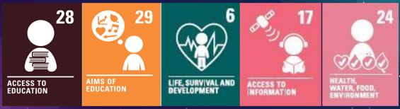
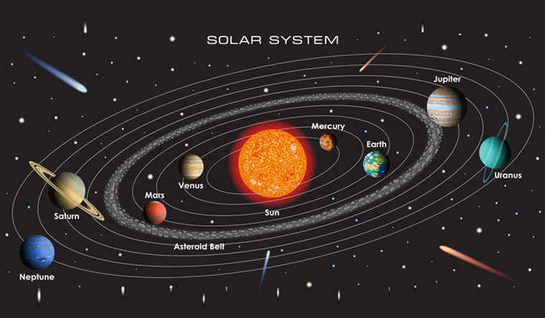
Focus: Earth and Space
Newall Green Primary School: Knowledge Organiser
Science: Space Term: Spring 2
Year group: 5 Date: February 2026
Key vocabulary:
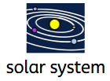Solar system: The solar system consists of the sun and everything that orbits, or travels around, the sun.
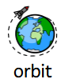Orbit: the path of an object around a particular point in space, for example the path the Moon takes around the Earth.
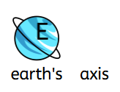Axis: is an imaginary line an object turns around and goes through the centre of a planet.
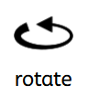Rotate: to spin round an axis.
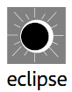Eclipse: a complete or partial hiding of the sun caused by the moon's passing between the sun and the earth
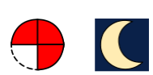Gibbous moon: occurs when the Moon is more than half-illuminated but not yet fully lit, appearing "humped" or "swollen"
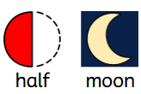Half-moon: The first half moon is when half of the lit portion of the Moon is visible after the waxing crescent phase.
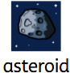Asteroid: is a chunk of rock and metal in outer space that is in orbit around the Sun (they vary in size).
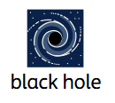Black hole: are the strangest objects in the Universe. A black hole does not have a surface, like a planet or star.
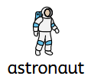Astronaut: is a person who is specially trained to travel into outer space.
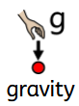Gravity: is the force by which a planet or other body draws objects toward its centre.
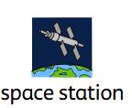Space station: is a spacecraft in a fixed orbit around the Earth.
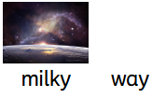Milky way: a broad band of light that stretches across the sky and is caused by the light of a very great number of faint stars.

What I should already know:
- The name of the 8 planets (Pluto is now not a planet)
- The order of the planets which orbit the sun
- How many days and weeks there are in a year, how many hours there are in a day.
- The Earth has a Moon
- That there are two hemispheres (Northern and Southern)
- Who goes up to space and who was the first man on the Moon.

Scientist: Galileo Galilei
Known for: Improving telescopes and discovering moons of Jupiter.

- WALT 1: Describe the movements of the Sun, Earth and Moon. DITLF
- WALT 2: Recognise how the Earth's tilt creates seasons
- WALT 3: Learn about the phases of the Moon
- WALT 4: discover how theories about our solar system have changedDITLF
- WALT 5: Investigate the planets in our Solar System
- WALT 6: Understand the objects that make up the Solar System

