









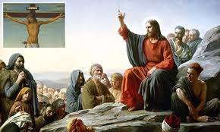
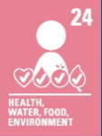
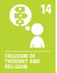


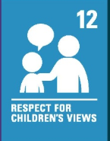
CVV
CVV
CVV
CVV
WALT 1: Understand Jesus’ values and what his mission was
Absent Intervention
WALT 2: Recognise the importance of love in Christianity
Absent Intervention
WALT 3: Understand forgiveness through Jesus’ parables DITL
Absent Intervention
WALT 4: Recognise how Christians try to follow Jesus’ teachings about justice and fairness
Absent Intervention
WALT 5: Understand greed and generosity through the teachings of Jesus
Absent Intervention
WALT 6: Explore ways Jesus can help solve modern day problems DITL
Absent Intervention
END OF UNIT QUIZ
Absent Intervention

Key Vocabulary
God – the creator and ruler of the universe and source of all moral authority; the supreme being
Jesus Christ – the Jewish religious teacher whose life, death, and resurrection are the basis of the Christian message.
prophet – an individual who is regarded as being in contact with a divine being and is said to speak on behalf of that being such as God
existence – the state of being real, or of being known or recognized
persecution- subject someone to hostility and ill-treatment
judgement – an opinion or persecution
parable – a short story to help teach the morals of Jesus
interpretation – an explanation or understanding of something
forgiveness – letting go of sin

.

CVV
CVV
CVV
CVV
What I should already know:
- The difference between facts, opinions and beliefs
- How religious and non-religious people believe the world was created
- Ways people perceive God
- Reasons why people believe (or not) in God
- There is more than one version of ‘truth’
- No believer has exactly the same views as each other
- People’s beliefs on life and death are different
- Holy texts are open to interpretation

Focus: What would Jesus do?
CVV
CVV
Newall Green Primary School: Knowledge Organiser
R.E: Christianity Term: Spring 2 Year group: 5 Date: April - June 2026
CVV

