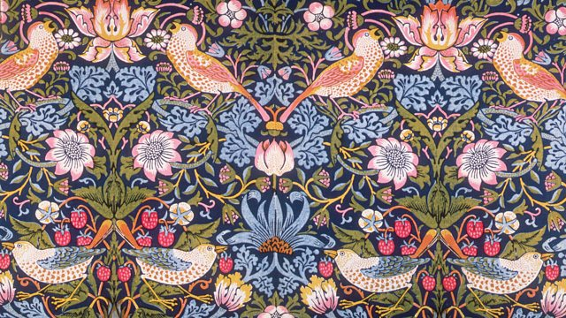
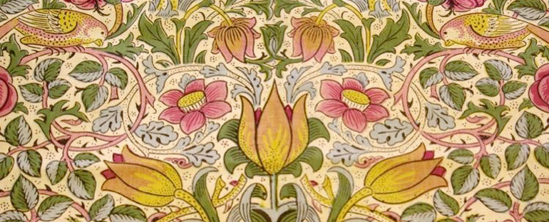
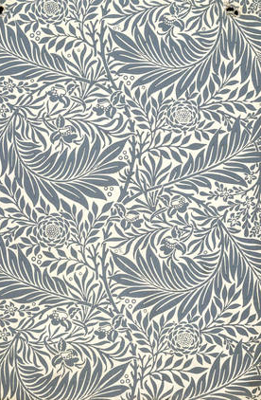
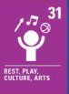
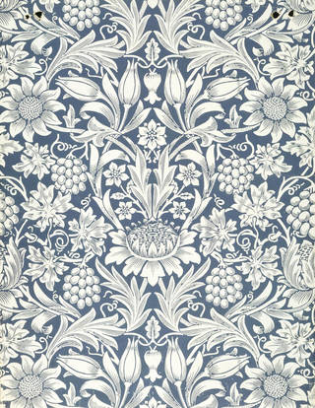
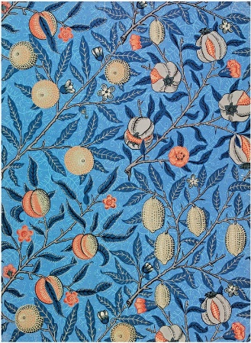
WALT 1: Explore the life and work of William Morris
WALT 2: To use line and colour to repeat a detailed pattern
WALT 3: To design your own wallpaper
WALT 4/5: To create and print your wallpaper
WALT 6: To evaluate my piece of art
Supporting pictures:
Key facts to retain:
- Who William Morris was.
- What Morris is famous for.
- How William Morris created his work.
- The influences that inspired the patterns he created.

What I should already know:
- How to create simple line drawings using pencil.
- How to create different lines using a pencil.
- Which primary colours are mixed to create secondary colours?
- How to mix colours to create different tones.
- How to blend different colours together.
- How to create repeated patterns.
- How to create reflected patterns using mirrors.
Newall Green Primary School Knowledge Organiser
Art Focus: William Morris Year group: 5 Term: Spring 2 Date: February and March 2026
Key Vocabulary:
Pattern  – a repeated decorative design.
‘Half drop’ pattern – the pattern is repeated horizontally and vertically but is dropped by half on each vertical line.
Motif 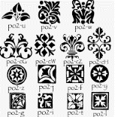– a recurring theme or pattern that appears throughout the work.
Textiles  – a type of cloth or woven fabric.
Texture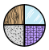 – in 2D work, refers to the visual ‘feel’ of the artwork.
Line drawing – a drawing done using only narrow lines, without blocks or shading.
Blend  – intermingling two or more colours or values to create a gradual transition or to soften lines.
Hue 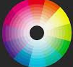– the colour.
Tint  – refers to any hue or mixture of pure colours to which white is added.
Tone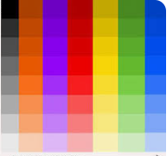 – the lightness/darkness of a colour.
Shade  – refers to any hue or mixture of pure colours to which black is added.

