Year 5 | Spring 2
Oracy type: Playscript.
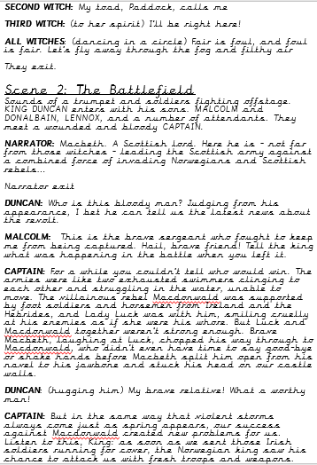
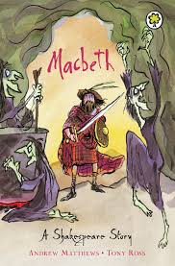
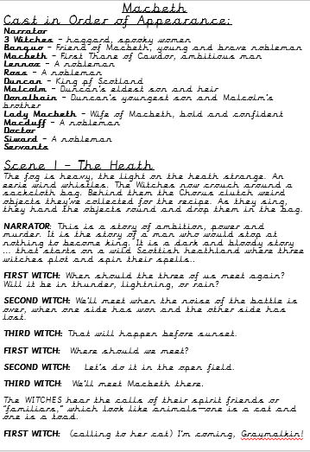
Oracy purpose:
To write and perform the ending to Macbeth with a group.
Key Oracy opportunities:
WALT 1: Hook – explore and perform short playscripts.
WALT 2: Complete box criteria and discuss and highlight features of a
playscript
WALT 3: Understand the layout of a playscript (DITL)
WALT 4: Explore expression and intonation (DITL)
WALT 5: Watch performance of Macbeth
WALT 6: Plan the end scene to Macbeth in groups (DITL)
WALT 7: Write the end scene to Macbeth in groups (DITL) over 2 lessons
WALT 8: Perform scenes to an audience and evaluate the effectiveness of our own and other performances- over 2 lessons (record on iPad)
Key oracy features:
- Listen and respond to other characters
- Use a wide range of words related to time
- Use a wide range of verbs to express thought
- Articulate clearly
- Use appropriate intonation and expression
- Develop a role
- Understand and communicate that characters will respond differently in certain situations
- Change volume and tone to grab listener’s attention
- Understand the interests of the listener
- Evaluate the effectiveness and impact of their own and other’s performance
My oracy targets:
____________________________________________________________________________________________________________________________________________________________________________________________________________________________________________________________________________________________________________________________________________________________________________________________________________

