Year 5 | Spring 2
Text type: Diary Entry.
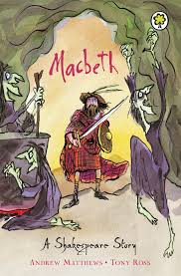
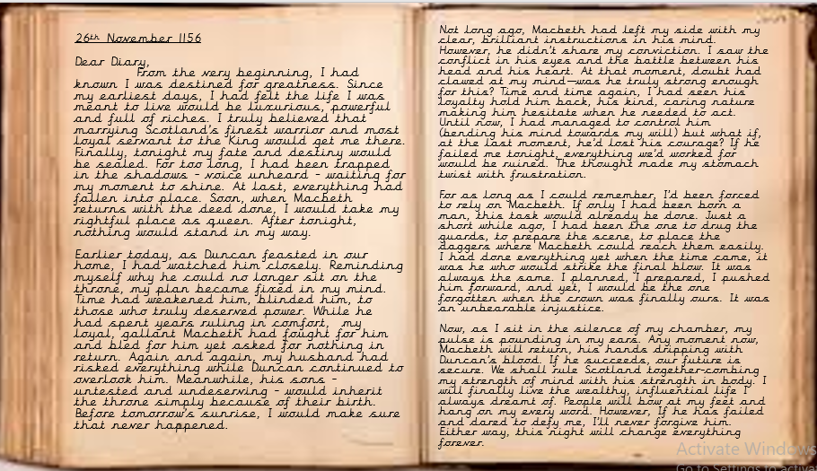
Writing purpose:
To write a diary entry from the perspective of Lady Macbeth or Macbeth.
Key Writing opportunities:
WALT 1: Hook – use diary entries to solve a crime.
WALT 2: Find the features of a diary entry
WALT 3: Explore Macbeth’s thoughts and feelings (DITL)
WALT 4: Explore Lady Macbeth’s thoughts and feelings (DITL)
WALT 5: Create conscience alleys for both characters linking to thoughts and feelings
WALT 6: Start to plan a diary entry as either Macbeth or Lady Macbeth
WALT 7: Use time adverbials within our diary entries
WALT 8: Write a diary entry (over 3 lessons)
WALT 9: Edit our diary entries
WALT 10: Publish our diary entries and create a class Lady Macbeth and Macbeth diary
Key features:
- Date
Expanded noun phrases
Subordinate clauses
Coordinating conjunctions
Parenthesis
Relative clauses
- First person
- Informal greeting
- Informal language
- Past tense
- Introductory paragraph
- Describes events in chronological order
- Paragraphs around one theme
- Thoughts and feelings
- Rhetorical questions
- Time adverbials
- Concluding paragraph
My writing targets:
____________________________________________________________________________________________________________________________________________________________________________________________________________________________________________________________________________________________________________________________________________________________________________________________________________

