Year 5 | Spring 2
Text type: Imagery poem.
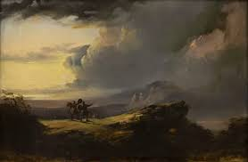
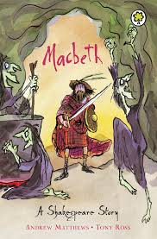
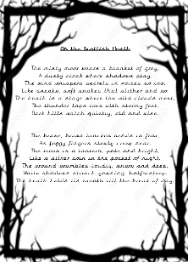
Writing purpose:
To create an imagery poem describing the heath where the three witches meet.
Key Writing opportunities:
WALT 1: Hook – create a sensory map and soundscape.
WALT 2: Explore imagery poetry examples and highlight features of an imagery poem.
WALT 3: understand and use imagery features to create a plan
WALT 4: Write an imagery poem
WALT 5: Perform an imagery poem to the class
Key features:
Expanded noun phrases
- Rhyming couplets
- Stanzas
- Alliteration
- Metaphors
- Similes
- Personification
- 14 Lines
My writing targets:
____________________________________________________________________________________________________________________________________________________________________________________________________________________________________________________________________________________________________________________________________________________________________________________________________________

