Year 5 | Term: Spring 1
Text type: Narrative
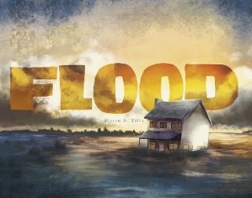
Writing purpose:
To write a full narrative based on a flood using the stimulus of the picture book
Key Writing opportunities:
WALT 1: Hook
WALT 2: Explore the text through sequencing
WALT 3: Identify features of a narrative
WALT 4: Write a setting description
WALT 5: Explore speech using freeze-frames DITL
WALT 6: Use speech to move the narrative on
WALT 7: Add final details to our plans
WALT 8: Write a narrative- over 5 lessons
WALT 9: edit our writing
Key features: Gold Star Features:
Opening | *Co-ordinating conjunctions
Build Up | *Subordinate clause
Dilemma | *Relative clause
Resolution | *Parenthesis
Ending | *Expanded noun phrases
Character description | *Fronted adverbials/Time adverbials
Setting description | *Parenthesis
Paragraphs around a theme | *Parenthesis
Direct speech with correct punctuation | *Parenthesis
Third person | *Parenthesis
Past tense | *Parenthesis
My writing target:

