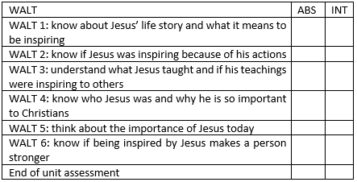


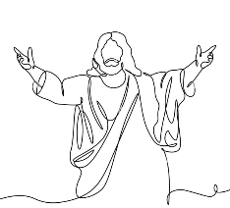
Key facts:
- Connections can be made between some of Jesus’ teachings and the way Christians live today.
- Christians celebrate Holy week and Easter Sunday which are crucial within Christianity.
- Jesus is inspirational to not only Christians but other religions around the world.
- Jesus chose different symbols which relate to himself using ‘I am sayings’.
- Although the Gospels say a lot about what Jesus said and did, there is no written description of what he looked like, and paintings were not done until maybe 150 years after his death.
- Jesus is said to have performed different miracles which have inspired Christians in different ways.
- Holy week is the last week of Jesus’ life.
- Christianity has over 2 billion followers.
- Christians believe that Jesus is God who came to earth in human form (Incarnation).

Vocabulary
Parables - a short story used to illustrate a moral or spiritual lesson.
The Beatitudes- 8 blessings recounted by Jesus.
Being inspired – If someone or something inspires you, they give you new ideas and a strong feeling of enthusiasm.
Gospels- 4 famous teachings of Jesus Christ. Gospel means ‘Good News’
Incarnation- the Christian belief that God took human form by becoming Jesus. Incarnation literally means ‘to take on flesh’.
Miracle- an extraordinary and astonishing event that is attributed to the presence and action of an ultimate or divine power.
Holy week- The week before Easter, starting on Palm Sunday.
Easter- marks the Resurrection of Jesus, 3 days after his death by crucifixion.

Why is Jesus inspiring to some people?
What I should already know:

- Different Christian beliefs.
- How different Christians show their beliefs in Church and at home.
- How different religions pray.
- Different festivals which are celebrated by a range of religious and non-religious people.
- What Christians believe about God.
- That Christianity is followed around the world.

Newall Green Primary: Knowledge Organiser for RE Year Group: 4 Spring 1

