Depicting the weather
Key Vocabulary
Tint- a mixture of a colour with white, which reduces darkness.
Tone- produced either by mixing a colour with grey, or by both tinting and shading.
Complementary colours- opposite to each other on the colour wheel, so they create a strong contrast.
Focal Point- the area the viewer's eye is naturally drawn.
Horizon- a horizontal line that runs across the paper to represent where the sky meets the ground.
Background and foreground - what is perceived as furthest away and closest to the viewer.
Primary colours- Red, yellow and blue
Secondary colours- Made by mixing two primary colours together to make orange, green and purple. 
What I should already know
ggf

Newall Green Primary: Knowledge Organiser for Art Year Group 4 Spring 1
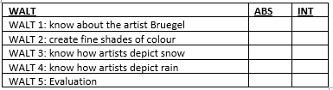
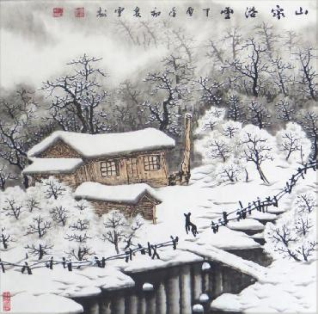
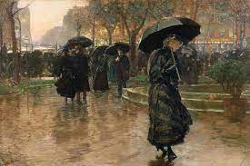
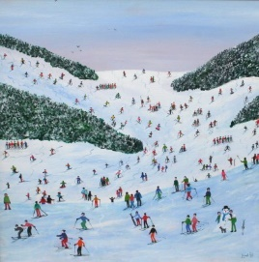
Key Knowledge
Pieter the Elder Bruegel ) was a Netherlandish renaissance painter and printmaker known for his landscapes and peasant scenes (genre painting).
In fine art, the term “Netherlandish renaissance" refers to the rapid development of fine art painting which occurred in Flanders and Holland during the 15th and 16th centuries.
Judy Joel is entirely self-taught and is best known for her naive style paintings which are fantastically fun colourful pieces.
Chinese snowscape paintings mainly show the grand snow scene of the northern part of China especially in the Northeast China region.
Art skills
Learn how to paint shades of different colours.
Learn how to lighten and darken colours.
The use of composition, perspective and horizon line.
Understand the concept of shade.
Use understanding of horizon, perspective and composition to sketch aspects of paintings in sketch books.
It is important to mix colours of paint on a separate sheet of paper so not to contaminate original colours.

I know that rain and snow are types of weather.
I know how to lighten and darken paint without using black and white.
I know what primary and secondary colours are.
I know what perspective, composition and horizon lines are in artwork.

