What I should already know
ggf
Key Vocabulary
Appliances – a device that performs a particular job
Atoms – the basis of all matter in the universe
Battery – a small device that provides power for electrical items
Bulb - uses electricity to create light.
Circuit - a complete route which an electrical current can flow around
Conductors - material or device that allows electricity to pass through it
Current - electrical flow caused when electrons move
Electricity – a form of energy which can build up in one place (static electricity) or flow to another (current electricity)
Insulators - a material or device that does not allow electricity to pass through it.
Wire - a long, thin piece of metal that carries an electrical current.

Electricity

Newall Green Primary School: Science Knowledge Organiser Year 4 Autumn 2

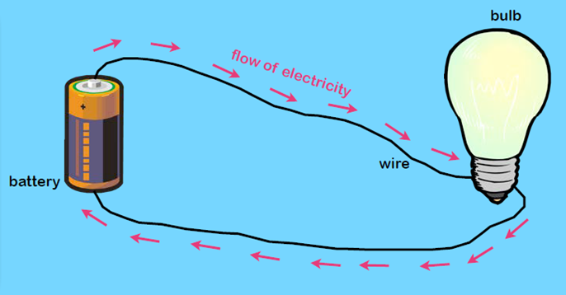
Key Knowledge
Identify common appliances that run on electricity and understand that it is a form of energy.
Understand that everything is made out of atoms and it’s their movement that makes electrical energy.
Identify different sources of energy (burning fuels, nuclear, wind, hydro and solar)
Understand how to keep safe around electrical appliances and how it is dangerous.
Name the different electrical sources we have in our homes (mains electricity.
Know how to construct simple circuits
Know and identify the purpose of different components that can be included in a circuit.
Understand what conductors and insulators are and recognise common examples.
Understand how to make a scientific experiment a fair test.
Know the difference between an independent, dependent and control variable.
Make a simple device which includes a circuit.
.
WALT | INT | ABS
WALT 1: To identify common appliances that run on electricity.

WALT 2: To understand how to keep safe around electrical appliances.

WALT 3: To construct simple circuits.

WALT 4: To recognise common conductors and insulators.

WALT 5: To make a simple device which includes a circuit.

End of unit assessment

I know that lights use electricity.
I know that electricity travels through wires.
I know that electricity powers appliances.
I know that electricity can be dangerous.

