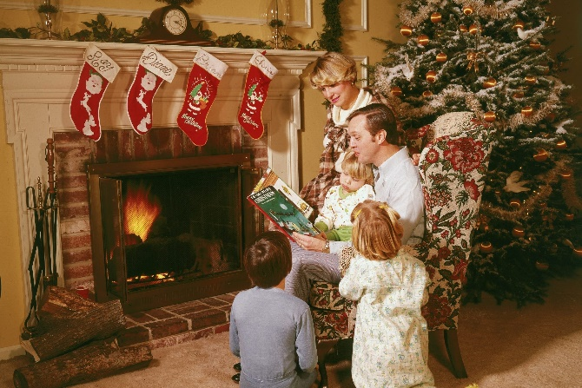
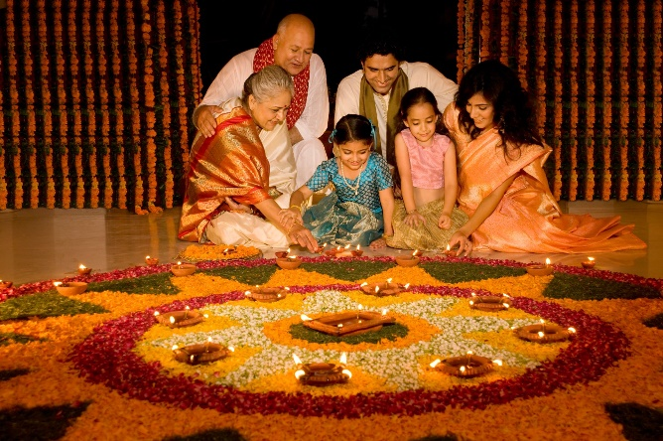
Key Facts
Religious Studies is one of the lenses we can use to examine RE. Religious Studies investigators look carefully at how religions are practised and why. They try to look at evidence and answer a question not as if they are a member of a religion, but from an investigators point of view.
Sociologists are interested in how society works; how people live and the relationships between groups and individuals.
Christmas is a festival celebrated around the world and not just by Christians. Other religions also celebrate it as well as people who don’t follow a religion.
Diwali always falls sometime between October and November. This five day festival honours Lakshmi, the goddess of wealth. Lamps are lit and windows and doors are left open to help Lakshmi find her way into people's homes.
How do people from religious and non-religious communities celebrate key festivals?
Vocabulary
Investigator – a person who carries out a formal investigation
Observations – a way of collecting data through looking at statistics, interviews and other methods.
Secular – not religious or connected to religious or spiritual matters.
Sociology – the study of human society and behaviours.
Survey – a set of questions people ask to collect data and information about a topic.
Diwali - Hindu celebration that marks the beginning of the Hindu New Year
Lakshmi – Hindu goddess of wealth

Newall Green Primary: Knowledge Organiser for RE Year Group 4 Autumn 2
I know that different religions celebrate different festivals.
I can recall facts about Christianity and understand how and why they celebrate Christmas.
I know that Hinduism is another religion that is celebrated and followed around the world and know what they believe in.
What I should already know
ggf

WALT 1 | Know how people celebrate Christmas using a religious studies lens.
WALT 2 | Know how people celebrate Christmas using a sociological lens.
WALT 3 | Compare what we know on how people celebrate Christmas.
WALT 4 | Explain what can we learn about how people celebrate different festivals.
WALT 5 | Discuss what we know about festivals in Britain today.
WALT 6 | End of unit quiz

