Newall Green Primary School: DT Knowledge Organiser Year 4 Autumn 2
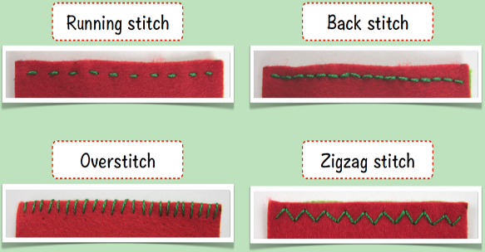
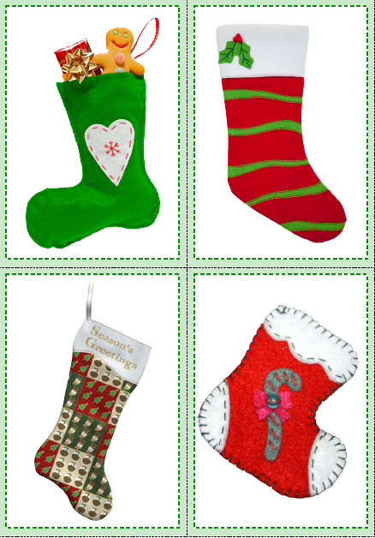
What I should already know
ggf
WALT | INT | ABS
WALT 1: To explore and analyse different products
WALT 2: To explore different ways to join fabric using sewing skills
WALT 3: To explore different ways to decorate fabric using sewing skills
WALT 4: To design a Christmas stocking
WALT 5: To use sewing skills to make a Christmas stocking
WALT 6: To evaluate a finished product

Key Facts
The colour, fabric, size, decoration and joins used for a Christmas stocking can be divided into two main categories – function and visual appeal.
There are lots of different stitches that can be used to join two pieces of fabric together, including: Running stitch, Back stitch, Overstitch and Zigzag stitch.
There are many different decorative features, or techniques, that can be used to make a Christmas stocking visually appealing, such as: colour, texture, embellishments, , shapes and applique.
The design criteria are the specific goals that must be achieved in order for the product to be successful. Such as who the ‘product; will be for.
Christmas stockings can be evaluated in several ways, including: are the stitches strong and secure? Is the product visually appealing? Is the product appropriate for its intended user?

Christmas stockings

I know what a Christmas stocking is.
I know what items could go inside a Christmas stocking.
I know that Christmas stockings come in a range different colours and styles.
Vocabulary
Sewing - the craft of fastening or attaching objects using stitches made with a needle and thread.
Function – relates to how suited it is to its purpose. Size, joins and can affect this.
Visual appeal – how attractive and eye-catching something is. Colour, decoration and fabric can affect this.
Embellishments - a decorative detail or feature added to something to make it more attractive.
Felt - a non-fraying fabric which can be joined by gluing, stapling, hand stitching or sewing machine.
Thread - used for hand and machine stitching when joining textile materials and components.

