The
What I should already know:
People can be atheist, theist or agnostic.
Religious people follow specific teachings on how to live their lives and this affects their life after death.
Humanists believe that we only have one life and that we should do good things from our own motivation.
Key Vocabulary
secular | Not connected with religious matters.
religious | Relating to or believing in a region.
Heaven | A place of reward in the Christian view of the afterlife.
Hell | A place of punishment in the Christian view of the afterlife.
Janna | A place of reward in the Muslim view of the afterlife.
Jahannam | A place of punishment in the Muslim view of the afterlife.
eternal | Lasting or existing forever.
reincarnation | The rebirth of a soul in another body.
karma | Good or bad luck as a result of your actions.
moksha | Reaching freedom from the cycle of death and re-birth.
soul | The spiritual part of a person that some people believe continues to exist after the body has died.

WALT 1: Think about what will happen when we die.
WALT 2: Explore Christian and Muslim beliefs on life after death.
WALT 3: Explore the Hindu and Sikh belief of reincarnation.
WALT 4: Explore the beliefs of Humanists and atheists about life after death.
WALT 5 and 6: Consider the different ideas about what happens when we die and form our own opinion.
Non-religious views
At a funeral of a non-religious person, the life is celebrated for what was achieved and what was given to others. The focus is on the life lived, not on a life to come.
Key facts to retain:
Both Christians and Muslims believe their actions in life will be judged to determine where they go in the afterlife. Both of these religions believe in eternal life in a spiritual form

Hindus and Sikhs believe in reincarnation where when they die, their soul is re-born; how they lived their previous life (good and bad karma) determines what they are re-born as. They live their lives trying to achieve moksha / mukti by trying to be the best they can be.
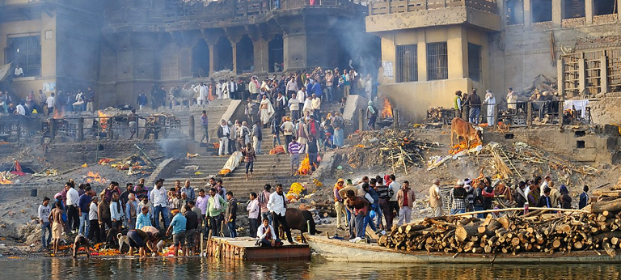
Knowledge Organiser for Spring 1 RE What do religions say when life gets hard? Year Group: 6

