Pair of Hounds, Stephen Park
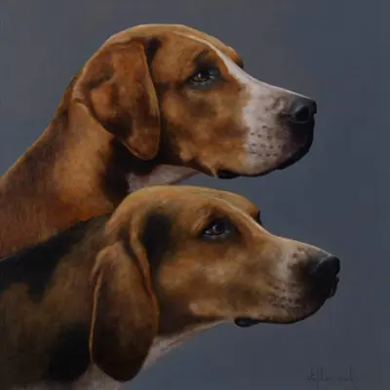
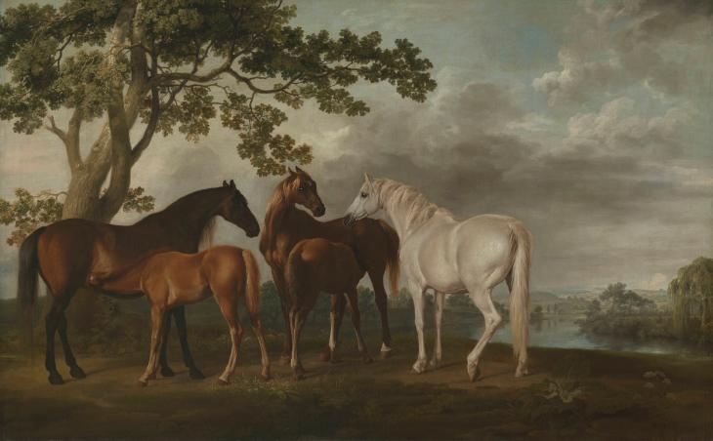
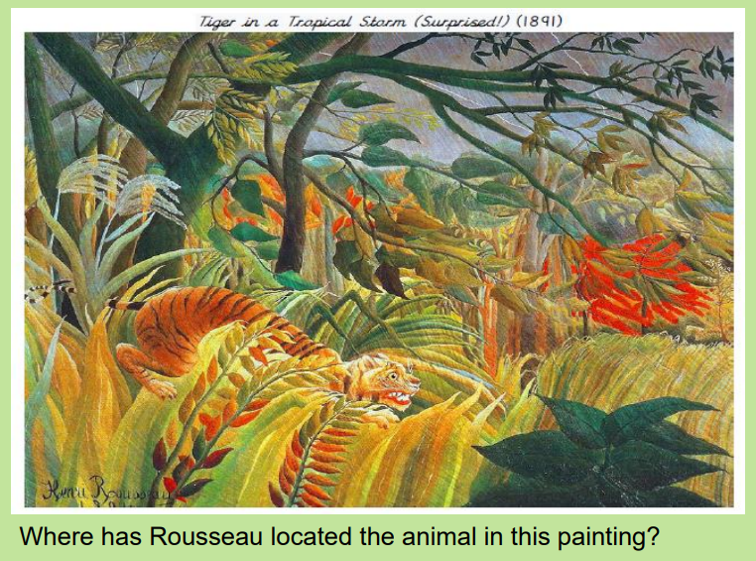
Tiger in a Tropical Storm,
Henri-Rousseau

We will be using ink to create shade and tone.
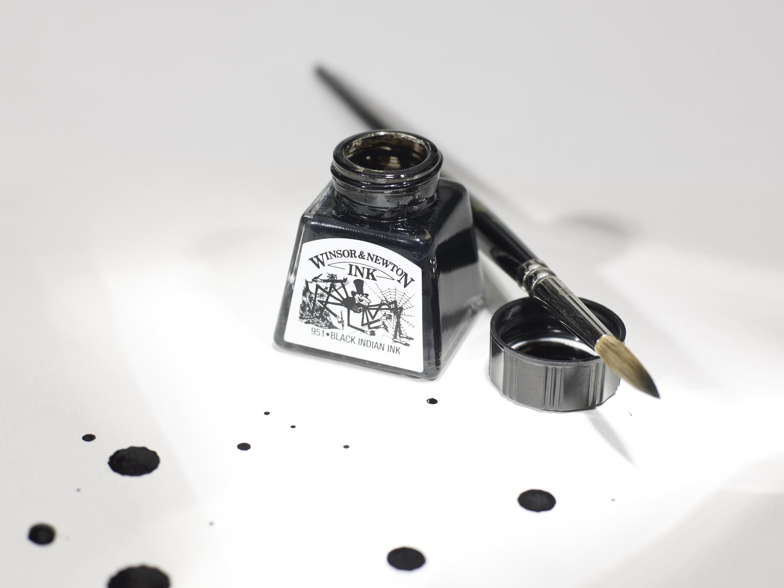
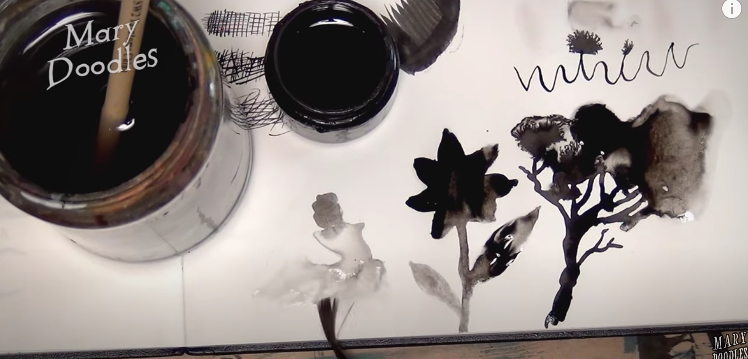

Key facts to retain:
Knowledge of anatomy was used by George Stubbs to ensure his paintings capture animals in a realistic way.
Shading can be used to create light and dark tones on an animal.
How multi-tones can be used to capture a realistic animal portrait.
Light tones can become darker but darker tones can never become lighter!

Mares and Foals in a River Landscape,
George Stubbs c.1763-8
What I should already know:
- How to hold a pencil
- The names of some famous artists
- Some artistic vocabulary
- The names of the primary and secondary colours
- The different tools and equipment to use to create different effects
- The names of different media (paint, charcoal etc)
- How to achieve different brush strokes

Key vocabulary:
Realism – artworks painted in a realistic almost photographic way.
Ink - a coloured fluid or paste used for writing, drawing, printing, or duplicating.
Composition - the combination of elements in a painting or other work of art that provides order or structure to the scene.
Shading – the darkening or colouring of a drawing with lines or blocks of colour. It is often used to create the illusion of depth or make an object three-dimensional.
Tone – how light or dark something is.
Multi-tone – A mixture of light-tones, mid-tones and dark-tones.
Trace – a copy made on a transparent sheet.
Outline - the line by which a figure or object is defined or bounded.
Medium: a medium refers to the materials that are used to create a work of art. The plural of medium is media.
Portrait - A category for artworks that capture the likeness of animals. These images might closely resemble human portraits in style, but with animals in the place of human subjects.
Newall Green Primary School: Knowledge Organiser
Spring 1: Realistic Art

