Key facts to retain:
The circulatory system is one of the most important in the body. It is made up of the heart, blood and blood vessels.
The main job of the heart is to PUMP blood around your body.
The heart sends blood to the lungs to be OXYGENATED. This means filled with oxygen.
The blood that arrives in the heart is DEOXYGENATED. This means that it has no oxygen left in it.
A drug is any substance that changes or alters our physical or mental state. Lots of drugs are legal and can be very beneficial. Others are illegal because they can be very harmful. However, some legal drugs can be harmful too.

What I should already know:
- That different foods provide you with different types of nutrition.
- The names and functions of different organs in the body.
Science knowledge organiser Healthy Bodies Year Group: 6 Spring 1
Vocabulary
circulatory system | Your circulatory system is made up of three parts: the heart, blood vessels and the blood itself.
blood vessel | Blood vessels are a series of tubes inside your body. They move blood to and from your heart.
arteries | Blood is pumped from the heart in the arteries.
veins | Blood is returned to the heart in the veins.
capillaries | Capillaries connect the smallest branches of arteries and veins
pulse | A rhythmical throbbing of the arteries as blood is propelled through them, typically as felt in the wrists or neck.
oxygenated blood | To add oxygen to blood.
deoxygenated blood | To remove oxygen from blood.
respiratory system | A series of organs responsible for taking in oxygen and removing carbon dioxide.
vitamins and minerals | Vitamins and minerals help the body to use other nutrients efficiently.
scurvy | Scurvy is caused by a lack of vitamin C in the diet
carbon dioxide | When you inhale (breathe in), air enters your lungs, and oxygen from that air moves to your blood. At the same time, carbon dioxide, a waste gas, moves from your blood to the lungs and is exhaled (breathed out).
oxygen | When we inhale (breathe in), air enters our lungs and oxygen from the air is transported from our lungs to our blood
lungs | Organs that enable us to breathe and take in oxygen.
heart | The function of the heart is to pump blood around the body so that the oxygen in the blood (taken from the lungs) can be delivered to the rest of the body.

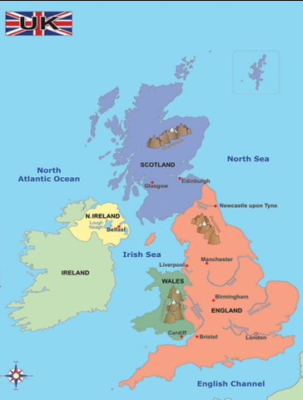
Do you know what each does?
Vitamin A – vital for good eyesight.
Vitamin E – helps your immune system.
Vitamin K - helps heal wounds.
Carbohydrates – provides your body with energy.
Protein – helps you grow and repair your body.
Fibre – keeps the digestive system working.
Fats – a source of energy, provide insulation, prevent damage to organs.
James Lind (4 October 1716 – 13 July 1794) was a Scottish doctor. By conducting one of the first ever clinical trials, he developed the theory that citrus fruits cured scurvy.
PEPOPLE I AM LEARNING ABOUT
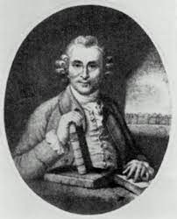
DID YOU KNOW?
A person's blood vessels could wrap around the planet approximately 2.5 times!

