WALT 1: Explain how we have day and night – (DITL)
WALT 2: Understand lines of longitude and time zones
WALT 3: Use the International Date Line to explore time zones around the world
WALT 4: Explain what effect time zones have on travel
WALT 5: Plan a trip to a different time zone using digital maps
WALT 6: End of Unit Assessment

WALT 1: Explain how we have day and night – (DITL)
WALT 2: Understand lines of longitude and time zones
WALT 3: Use the International Date Line to explore time zones around the world
WALT 4: Explain what effect time zones have on travel
WALT 5: Plan a trip to a different time zone using digital maps
WALT 6: End of Unit Assessment

WALT 1: Explain how we have day and night – (DITL)
WALT 2: Understand lines of longitude and time zones
WALT 3: Use the International Date Line to explore time zones around the world
WALT 4: Explain what effect time zones have on travel
WALT 5: Plan a trip to a different time zone using digital maps
WALT 6: End of Unit Assessment

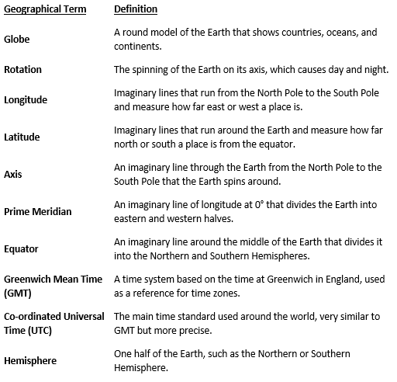
What I
of things like playdough and snow.

What I Should Already Know:
An understanding of how we have day and night.
Locate world’s countries and different geographical regions, including using an atlas.

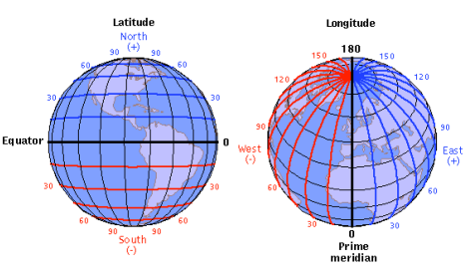
Key Facts to retain:
We will explain why we have day/night and what lines of longitude are.
We will identify the Prime Meridian.
We will understand what time zones are.
We will use the International date line to explore time zones around the world.
We will investigate the effect time zones have on travel.

Newall Green Primary: Knowledge Organiser for Time Zones Year Group 6 Spring 1
What I should already know
ggf
Geography
Names of the Oceans
Names of the continents
Countries in Europe
What climate is
Global Warming
Ozone

