#
Key Vocabulary
Soluble 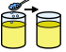 – a substance that can dissolve in liquid.
Insoluble 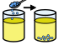 - a substance that cannot dissolve in liquid.
Solvent 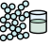– a liquid which the material dissolves in.
Solution 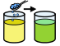 – a special type of mixture composed of two or more substances.
Solute 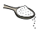 – a substance that dissolves in liquid.
Reversible 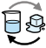– a chemical change where no new materials are created and the original material can be recovered.
Irreversible – A change is called irreversible if it cannot be changed back again. In an irreversible change, new materials are always formed.
Transparent 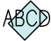 - if an object or material is transparent, it means light completely passes through it, and you can see clearly through it.
Opaque  – the object blocks light so that light cannot travel through the object.
Flexible  – how bendable something is. The more bendable it is the more flexible it is.
Rigid 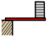 - the ability of a solid to change its shape. That is, when an external force is applied to a solid material, the shape does not change.
Substance  – a chemical element and its compounds in the natural state or manufacturing process.

WALT 1: To investigate that some materials dissolve in liquid.
Intervention Absent
WALT 2: Use knowledge of solids, liquids and gasses to decide how mixtures and solutions can be separated. Day In The Life
Inter Absent
WALT 3: To explain that some changes form new materials.
Intervention Absent
WALT 4: Identify when a change caused by heating or cooling is reversible or irreversible.
Intervention Absent
WALT 5: To compare and group together everyday materials on the basis of their properties. Day In The Life
Intervention Absent
WALT 6: To give reasons for the particular uses of everyday materials in their relation to their properties.
Intervention Absent
END OF UNIT QUIZ
Intervention Absent
Newall Green Primary School: Knowledge Organiser
Science – Properties and changes of materials Term: Spring 1/January 2026
Properties and changes of materials

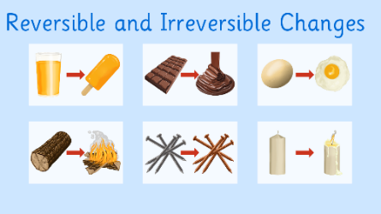
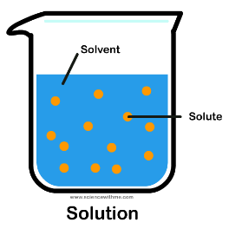
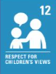
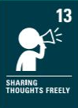
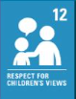
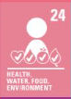
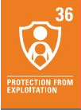
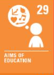
What I should already know:
- To know what material an object is made from
- Describe the simple properties of a material
- Identify a variety of materials
- Compare and group everyday objects based on their material
- Identify and compare the suitability of everyday objects for particular uses
- How solid objects can be changed by manipulation

