#
Key Vocabulary
God  – The creator and ruler of the universe and source of all moral authority; the supreme being.
Belief - An acceptance that something exists or is true, especially one without proof.
Church  – A building used for public Christian worship.
Synagogue – the building where a Jewish assembly or congregation meets for religious worship and instruction.
Mandir  – A Hindu temple.
Worship – Used in addressing or referring to an important or high-ranking person.
Existence – The state of being real, or of being known or recognized.
Religion 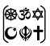- A personal set or institutionalized system of religious attitudes, beliefs, and practices.
Pilgrimage – A journey, often into an unknown of foreign place.
Valuable – A thing that is of great worth, especially a small item of personal property.
Community  - The condition of sharing or having certain attitudes and interests in common.
Alternative – Perspectives which differ from those which are ‘conventionally’ understood.

WALT 1: Can I explain what a place of worship is?
Intervention Absent
WALT 2: Can I explain what a Hindu place of worship is and what it is used for? Day In The Life
Intervention Absent
WALT 3: Can I explain what a Jewish place of worship is and what it is used for?
Intervention Absent
WALT 4: Can I explain what a Christian place of worship is and what it is used for? Day In The Life
Intervention Absent
WALT 5: Can I discuss ideas about the importance of people in a place or worship, rather than the place itself?
Intervention Absent
WALT 6: Can I explain what a place of worship means to believers? Day In The Life
Intervention Absent
END OF UNIT QUIZ
Intervention Absent
Newall Green Primary School: Knowledge Organiser
R.E – If God is everywhere, why go to a place of worship? Term: Spring 1 Date: January 2026
Focus: What is a place of worship? What is it for? What is a Christian place of worship? What is a Hindu place of worship? What is a Jewish place of worship? Are people more important than the place?
Christianity/Hinduism/Judaism

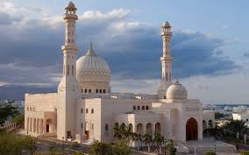
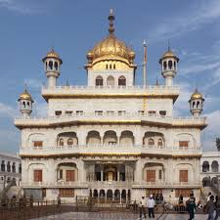
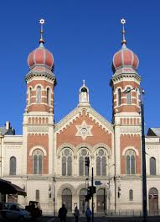
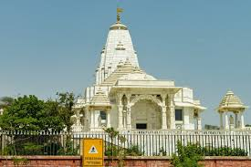
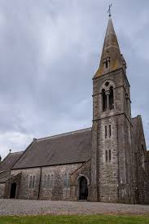

Places of worship
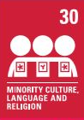
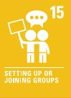
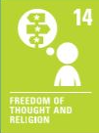
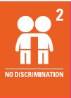


Peace religion link: Zoroastrianism
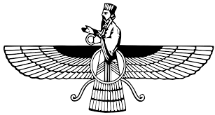

What I should already know:
- Places of worship for differing religions.
- Not every member of a faith or religion is going to believe in the exact same principles.
- Name some features of places of worship.
- How different religions perceive God.
- Sacred texts range from the Bible, Quran, Torah, Veda, and The Guru Granth Sahib etc
- These texts are interpreted to bring meaning to reality
- Different views on how Christians believe God created the world.

