Year 5 | Spring 1
Text type: Explanation Text.
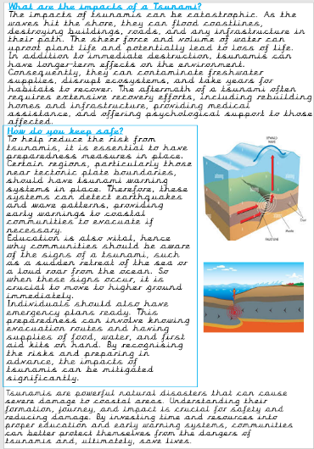
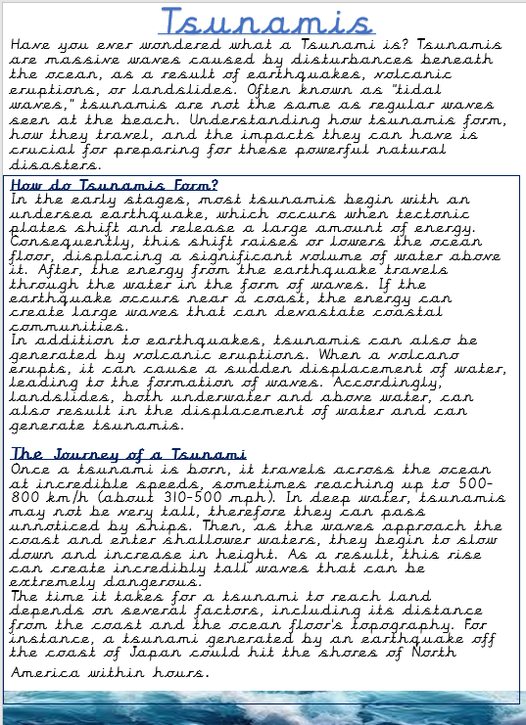
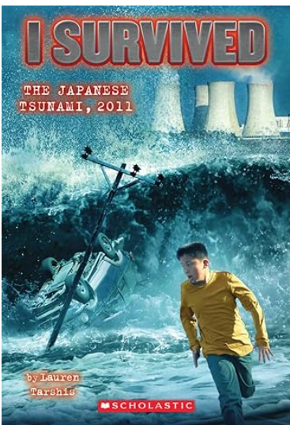
Writing purpose:
To create an explanation text about tsunamis.
Key Writing opportunities:
WALT 1: Hook – create a class presentation about earthquakes.
WALT 2: Explore explanation text examples and create a box criterion.
WALT 3: Discuss and highlight features of an explanation text.
WALT 4: Research tsunamis and use technical vocabulary
WALT 5: Use causal conjunctions
WALT 6: Use relative clauses to expand our ideas
WALT 7: draft an opening
WALT 8: draft a conclusion
WALT 9: Create an explanation text
WALT 10: Edit our writing
Key features:
- Title
- Subheadings
- Subordinate clauses
Relative clauses
- Parenthesis
- Fronted adverbials
- Co-ordinating conjunctions

- Introductory paragraph
- Technical Vocabulary
- Diagram/illustration with labels
- Time adverbials
- Chronological order
- Causal Conjunctions
- Conclusion
- Present tense
- Third person
My writing targets:
____________________________________________________________________________________________________________________________________________________________________________________________________________________________________________________________________________________________________________________________________________________________________________________________________________

