
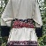
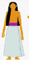
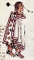
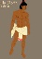
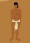
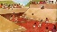
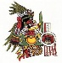
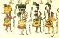
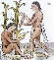
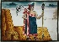
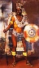
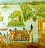
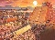
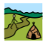
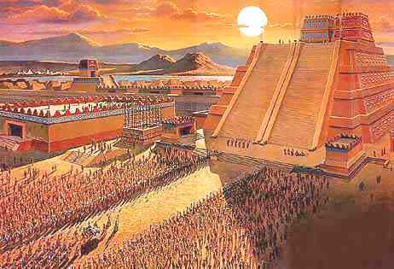
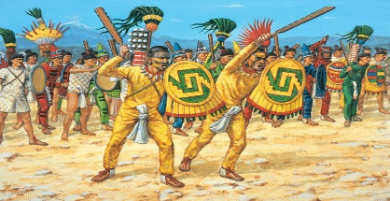
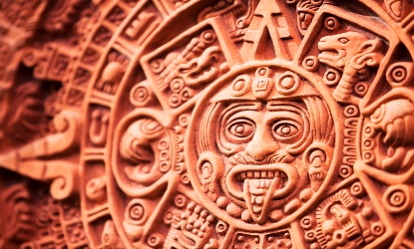
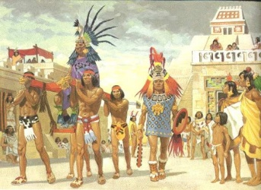
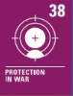

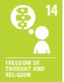
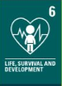
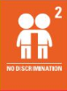
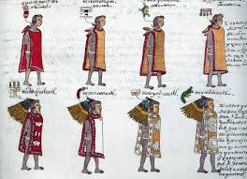
CVV
CVV
CVV
CVV
CVV
CVV
Key Vocabulary
Nomad – A person that does not stay in the same place long. A traveller.
Tenochtitlán – The capital city in the Aztec empire.
Chinampas – a small floating area of fertile arable land that was built up by vegetation.
Huey Tlatoani – The supreme leader of the Aztecs.
Alcalde – A mayor.
Macehualtin – The common people in Aztec society.
Pipiltin – the nobles in Aztec society.
Cihuacoatl – A person in charge of religious ceremonies.
Ullamaliztli – A ballgame played by the Aztecs.
Maxtlatl – A loin cloth.
Xiuht-lulpill – A hip cloth.
Tilmahtli – A cape or robe.
Cuēitl – A long skirt.
Cihua necuitlalpiloni – A sash used to tie the skirt on.
Huipil – a blouse
Quechquemitl/ Xicolli – Religious clothing.

What I should already know:
- What an empire is
- How empires grow and build strength over time
- A range of different facts about other polytheist societies and religions.
- Tudor timeline of events that happened at the same time historically

CVV
CVV
CVV
CVV
CVV
CVV
Newall Green Primary School: Knowledge Organiser
History: The Aztecs Term: Spring 1 Year group: 5 Date: Jan – March 2026
CVV
WALT 1: Recognise that The Aztecs once ruled Mexico
Absent Intervention
WALT 2: Understand how The Aztecs lived DITL
Absent Intervention
WALT 3: Understand what foods The Aztecs ate
Absent Intervention
WALT 4: Understand how The Aztecs dressed DITL
Absent Intervention
WALT 5: Recognise the importance of religion and worship in The Aztec Empire
Absent Intervention
WALT 6: Know who Hernan Cortez was
Absent Intervention
WALT 7: Understand the fall of The Aztec Empire
Absent Intervention
END OF UNIT QUIZ
Absent Intervention

Focus: The Aztec Empire

