NEW Topic overview 2025-2026 Year group: 5

 |  | Autumn 1 | Autumn 2 |  |  | Spring 1 |  | Spring 2 | Summer 1 |  | Summer 2
Fluency focus | Class Novel  Must be read every day for 15 minutes  Monday & Friday GR focus | Holes by Louis Sachar |  |  | Treason by Bertie Doherty | I survived a Japanese Tsunami by Lauren Tarshis | Stories from Shakespeare by Geraldine McCaughrean |  | Black Powder by Ally Sherrick |  | The Last Bear by Hannah Gold
Fluency focus | Linked Reading Texts – Literacy shed +  Tue, Wed, Thurs  (for fluency, one text may need to be read a number of times) | Letters  Living things  The Tudors  Ancient Egyptians  Carnival  Mountains | The Shang Dynasty  Volcanos  Rainforests  Japan  Frankenstein  Christmas |  |  | Aztecs  Materials  Sci-fi  Romani tales  Natural resources  Eco-Global warming |  | William Shakespeare  Space  The Solar System  Illness and medicine  Down the mines |  | Forces  Weather  Suffragettes  Movies  Magic and mystery  Crime and punishment | British mythology  Traditional Greek myths  Titanic  Migration  Cornwall  Animals
Teaching Writing | Key stimuli for literacy  (to teach the features or vocab for the genre) | Holes  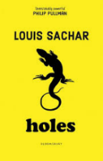 | Rembrance  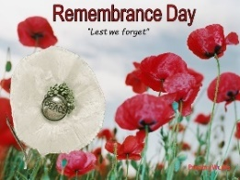  Treason  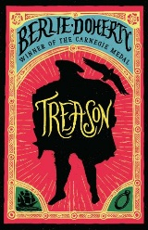 |  |  | I survived a Japanese Tsunami  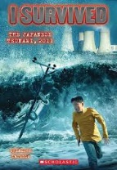  The Flood  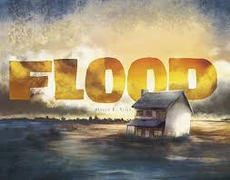 |  | Stories from Shakespeare  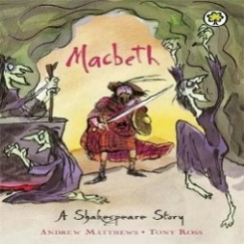 | Black Powder  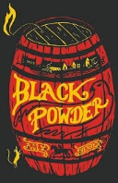 |  | The Last Bear  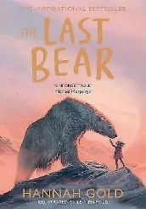
Teaching Writing | Text Outcomes | Holes  - Persuasive leaflet (Camp Green Lake)  - Formal letter (to the warden for Stanley to be let out)  - Newspaper report (shut down of the camp) |  | Remembrance poetry  See below  Treason  - Recount-Diary entry in the role as main character  - Narrative (write their own adventure story set in Tudor times based on Treason) |  | I survived a Japanese Tsunami  - Explanation text (tsunami)  The Flood  - Narrative (f full narrative based on a flood using the stimulus of the picture book.) |  | Stories from Shakespeare  - Poetry- see below  - Recount – to write a diary entry in role as a character from Macbeth.Romeo and Juliet)  - Play script – To write a play script inspired by William Shakespeare. | Black Powder  - Diary Entry - To write a diary from Tom’s perspective as a Catholic child.  - Informal letter to Mum in gaol  - Debate – should Tom follow through with Falcon’s plan? Linked to RR. |  | The Last Bear  - Non-chronological report – on an endangered animal of their choice.  - Narrative – To write a narrative based around their endangered animal.  - Persuasive campaign poster – raise awareness of the impact on climate change.
 | Oracy | Use relevant strategies to build their vocabulary- Use a range of words related to time and measure.  Consider and evaluate different viewpoints, attending to and building on the contributions of others. | Articulate and justify answers, arguments and opinions  Debate a point- e.g. why a character in the book did the right thing? |  |  | Ask relevant questions to extend their understanding and knowledge using games such as ‘The Question Game’ - pupils decide on a topic, one pupil asks an open-ended question, and the other pupil responds with a related open-ended question e.g. A. Why is there a light on? B. Where does light come from |  | Participate in discussions, presentations, performances, role play/improvisations & debates  Speak audibly and fluently with an increasing command of Standard English  Sonnets- Romeo and Juliet | Maintain attention and participate actively in collaborative conversations, staying on topic and initiating and responding to comments. |  | Give well-structured descriptions, explanations and narratives for different purposes, including for expressing feelings  News report (from an event in the book)
 | Poetry |  | Remembrance  Emotive, performance poetry |  |  |  |  | To write an imagery poem inspired by Macbeth.- The Witches/Heath
 | Rights Respecting Gold evidence | Black history focus | Remembrance poetry |  |  |  |  |  |  |  | Climate change
 | Trips/Visitors | Ordsall Hall – Tudors |  |  |  | Manchester Cathedral (Lent) |  | Beeston Castle – Geography (self-led) | River Trip - Geography (Venture Out)
 | Celebrations/ festivals/  special events | Black History Month  National Poetry Day | Anti-bullying  Harvest Festival  Christmas  Remembrance Day  Diwali |  |  | Children’s mental health week  Shrove Tuesday |  | World book day  Science week?  Easter | Walk to School Week  Eid  Sports Day |  | End of year parties
 | Parents/ carers involvement | Parents’ Evening  Welcome presentation to parents | Class Assembly  Arts and Crafts (Christmas) Parent morning |  |  |  |  | Parents' Evening  Target setting morning (Easter)  Class Assembly |  |  | Celebration Assembly  End of Year Reports  Sports Day
 | Maths | Number: Place Value  Number: Addition and Subtraction | Number: Multiplication and Division A  Number: Fractions |  |  | Number: Multiplication and Division B  Number: Fractions B |  | Number: Decimals and Percentages  Measurement: Perimeter and Area  Statistics | Geometry: Shape  Geometry: Position and Direction |  | Number: Decimals  Number: Negative numbers  Measurement: Converting units  Measurement: Volume
 | Science | Life Cycles | Changes and Reproduction |  |  | Properties and changes of Materials |  | Earth and Space | Forces in Action |  | Forces in Action
 | History | Tudors  Articles: 2, 4, 6, 13, 14, 15, 19, 28, 30, 31, 36, 37 and 38 |  |  |  | Aztecs  Article 4, 6, 13, 14, 19, 27, 28, 38 |  |  |  |  | Stuarts  Article 2, 4, 6, 13, 14, 22, 19, 11, 30, 35, 38
 | Geography |  | Cities in the UK |  |  |  |  | Maps and Beeston Castle | Rivers
 | RE/Peace Mala | Why do some people believe God exists?  Link- Zoroastrianism | What does it mean to be a Muslim in Britain today?  Link- Zoroastrianism |  |  | If God is everywhere, why go to a place of worship?  Link- Zoroastrianism |  | Can we live by the values of Jesus in the twenty-first century?  Link- Zoroastrianism | Green religion? How and why should religion communities do more to care for the Earth?  Link- Zoroastrianism
 | PSHE/Dimensions | Keeping safe | Relationships and sex education |  |  | Mental and emotional health |  | Healthy Lifestyles | Living in the wider world
 | PE | Basketball  Cricket | Football  Dodgeball |  |  | Invasion Games  Football |  | Invasion Games  Fitness | Athletics  Tennis |  | Cricket  Rounders
 | Music | Melody and harmony in music | Sing and play in different styles |  |  | Composing and chords |  | Enjoying musical styles | Freedom to improvise |  | Battle of the bands
 | ICT | Systems and searching | Creating media- videos |  |  | Programming A- selection in physical computing |  | Data and information | Creating media- vector graphics |  | Programming B- selection quizzes
 | Art | Self-portraits – accurate drawings Holbein | Self-portraits and hidden messages - Arcimboldo |  |  | Self-portraits – Frida Kahlo |  | Block printing -William Morris | Painting movement - Flemish Art |  | Still life – Louise Moillon
 | DT |  | Building Bridges (Thomas Pritchard) |  |  |  |  | Textiles (Stephanie Kwolek) |  |  | Chinese Inventions (Cai Lun)
 | French | Monster Pets | Shopping in France |  |  | French speaking world |  | The Solar System | Verbs |  | French family

