Topic overview 2024-2025 Year group: 3
 |  | Autumn 1 | Autumn 2 | Spring 1 | Spring 2 | Summer 1 | Summer 2
Fluency focus | Class Novel  Must be read every day for 15 minutes  Monday & Friday GR focus | BFG  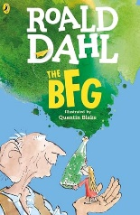 | The Legend of Kevin  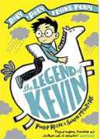 | Iron Man  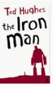 | The Twits  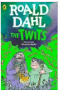 | The Lion, The Witch & The Wardrobe  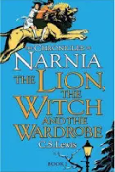 | The Last Bear  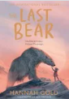
Fluency focus | Linked Reading Texts – Literacy shed  Tue, Wed, Thurs  (for fluency, one text may need to be reread) | The Orchestra  Stone age  Rocks and Fossils  Coasts  Wind on the hill (p) | Adventure Stories  Forces and Magnetism  Predators  Christmas  The Jumblies (P) | Art and Artists  Iron Age  Robots  My Shadow (P) | Healthy bodies  Italy  Angry Earth  Plants  The Eagle and  The Crocodile (P) | Romans  Light  Climate Change  Nursery Rhymes  Countries  From a Railway Carriage (P) | Architectural Design  Women in the skies  Habitats  Summer holiday reading detective  Old Possum’s Book of Practical Cats (P)
Teaching Writing | Key texts for literacy  (to teach the features or vocab for the genre) | The BFG  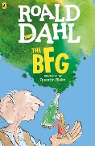  The Boy, the Mole, the Fox and the Horse (BBC Radio/teach) 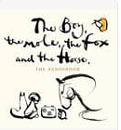 | It’s a no money day  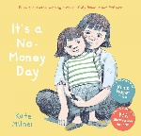  Stone Age Boy  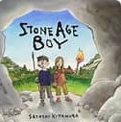  Christmas Pine  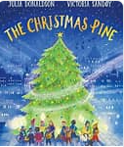 | Iron Man (15)  Journey (10)  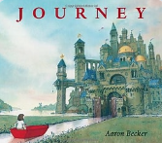 | The Twits (15) | The Mirror (10)  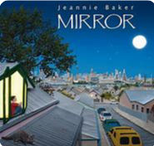  The Lion, The Witch & The Wardrobe (10) | Escape from Pompeii (30)  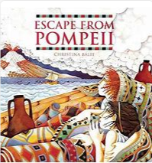  Dragonracers  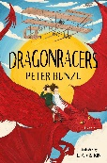
Teaching Writing | Text Outcomes | The BFG  Recipes  Informal letter to warn about giants. | My name is Not Refugee  Letter to MP  Stone Age Boy  Narrative | Iron man  Explanation Text  Journey  Adventure story | Twits  Narrative (design a new prank and write a chapter for the book).  Persuasive letter | The Mirror  Informal letters  The Lion, The Witch & The Wardrobe (10)  Narrative | Escape from Pompeii  Diary  Non-chronological report  Dragonracers  Persuasive advert (print)
 | Oracy/Poetry | The Boy, the Mole, the Fox and the Horse (BBC Radio/teach)  Play scripts | It’s a no money day  Campaign Speech  Christmas Pine  Poetry | Iron man  Descriptive poetry  (with Colourful Semantics Focus) | Twits  News report on one of the events. |  | Dragonracers  Persuasive advert (radio)
 | Rights Respecting Gold evidence |  | Campaign Speech about the need for food banks. |  | Respecting the rights of others.
 | Trips/Visitors |  | Stone Age Day |  |  |  | Roman Museum Chester
 | Celebrations/ festivals/  special events | National poetry day  Black history month | Stone Age Day  Harvest Festival  Diwali  Christmas  Remembrance Day | Children’s mental health week  Shrove Tuesday  Able science day | World book day  Science week  Easter | Walk to School Week  Eid  Able writers’ day | Sports day  End of year parties
 | Parents/ carers involvement | Parents’ Evening  Black History Month | Christmas Craft & Target Sharing morning | Half Year Reports | Easter target setting morning | Parents’ Evening  Sports Day | Showcase Assembly  End of Year Reports
 | Maths | Number: Place Value  Number: Addition and Subtraction | Number: Addition and Subtraction  Number: Multiplication and Division | Number: Multiplication and Division  Measurement: Length and Perimeter | Number: Fractions A  Geometry: Shape | Number: Fractions B  Measurement: Money  Measurement: Time | Measurement: Time  Measurement: Mass and Capacity  Number: Statistics
 | Science | Rocks, Fossils and Soils | Forces and Magnets | Health and Movement | How Plants Grow | Light and Shadow
 | History | The Stone Age |  | Bronze and Iron Age |  | The Romans
 |  | Articles: 2, 6, 8, 15, 19, 24, 27, 31 and 32. |  | Articles: 2, 6, 8, 15, 19, 24, 27, 31 and 32. |  | Articles: 2, 6, 7, 8, 15, 19, 24, 26, 27, 31 and 32.
 | Geography |  | Crystals and Gemstones |  | Italy and Pompeii |  | Earthquakes and Volcanoes
 |  |  |  |  | Articles: 6, 7, 8, 24, 26, 27, 30 and 31. |  | Articles: 6, 9, 24, 26 and 27.
 |  |  | Articles: 13 and 32.
 | RE/Peace Mala | L2.7: What does it mean to be a Christian in Britain today? | L2.10: How do family life and festivals show what matters to Jewish People? | L2.4: Why do people pray? | L2.5: Why are festivals important to religious communities? | L2.1: What do different people believe about God? | Earth Religions
 | PSHE/Dimensions | Relationships and sex education | Mental and Emotional Health | Keeping Safe | Healthy Lifestyles | Living in the wider world
 | PE | Athletics  Invasion Games | Gymnastics  Hockey | Dance  Basketball | Football  Netball | Cricket  Football | Tennis  Rounders
 | Music (Recorders) | Writing Music Down | Playing in a Band | Compose Using Your Imaginations | More Musical Styles | Enjoying Improvisation | Opening Night
 | ICT | Unit 1 - Computing systems and networks – Connecting computers | Unit 2 - Creating media - Stop-frame animation | Unit 3 - Programming A - Sequencing sounds | Unit 4 - Data and information – Branching databases | Unit 5 - Creating media – Desktop publishing | Unit 6 - Programming B - Events and actions in programs
 | Art | Pencil: how to draw using perspective | Paper: creating paper-mâché animals | Painting reflections | Creating silhouettes | Positive and negative space
 | DT |  | Storybooks |  | British Inventors |  | Light-up Signs
 | French | French greetings with puppets | French adjectives of colour, size and shape | French playground games – numbers and age | In a French classroom | French transport | A circle of life in French

