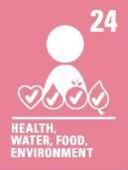
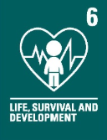
Key vocabulary:
Fertilization – 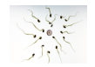It specifically involves the joining of the female reproductive cells with the male reproductive cell
Embryo - 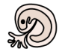An embryo is the earliest stage in the development of a fertilised egg (the zygote).
Development – 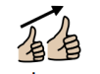The progressive changes in size, shape, and function during the life of an organism.
Gestation - 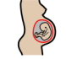The time between egg fertilisation and giving birth.
Infant/infancy – 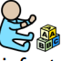The first year after birth is called infancy.
Childhood - 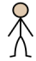The stage of a human organism between birth and adolescence.
Adolescence - 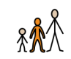 The period of life when a child develops into an adult.
Hormones – 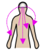They travel in your bloodstream to tissues or organs. They work slowly, over time, and affect many different processes, including growth and development. Metabolism - how your body gets energy from the foods you eat.
Puberty - 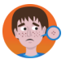Puberty is the stage in life when a child's body develops into an adult's body.

Newall Green Primary School: Knowledge Organiser
Science: Autumn 2 Year group: 5 Date: Nov 25
WALT 1: Recognise the stages of growth and development in humans.
Absent Intervention
WALT 2: Understand the stages in the gestation period of humans and compare them to other animals.
Absent Intervention
WALT 3: Recognise the stages of development during childhood and understand the needs at those stages
Absent Intervention
WALT 4: Understand the initial changes inside and outside of the body during puberty
Absent Intervention
END OF UNIT QUIZ
Absent Intervention

Focus: Changes and Reproduction
What I should already know:
- The names of parts of the plant.
- How some animals develop through the different stages of the life cycle.
- Recognise the factors that can cause extinctions.
- The key stages in the life cycles of the five animal groups, including similarities and differences.
- There are six distinct animal groups
  - Mammals
  - Fish
  - Birds
  - Reptiles
  - Amphibians
  - Invertebrates

Supporting experiences: PSHE curriculum.

