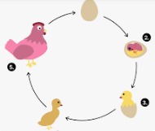
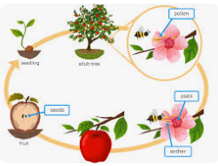
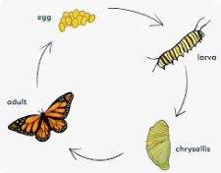
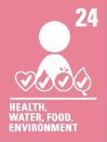
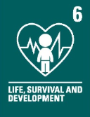
CVV
CVV
CVV
CVV
CVV
CVV
CVV
CVV
CVV
CVV
CVV
Key vocabulary:
Evidence - proof of the existence of something
Fact – A thing that is known or proved to be true
Alternative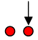– Perspectives, ideas and opinions that are different
Reproduction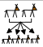 - the production of offspring by a sexual or asexual process
Asexual – reproduction without a sexual activity.
Life cycle 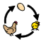 - the series of changes in the life of an organism
Naturalist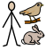 – an expert of natural history.
Male - the sex of an organism that produces
Female - the sex that can bear offspring or produce eggs
Offspring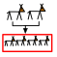- the young creation of living organisms

What I should already know:
- Plants, animals and humans are alive and breathe
- What plants and flowers need to grow and survive
- Different species of plants, flowers and animals
- The different habitats plants, flowers and animals live and survive.

Focus: Reproduction in plants, animals and humans including sexual and asexual
Newall Green Primary School: Knowledge Organiser
Science: Life Cycles – Humans, Animals and Plants Term: Autumn 1 Year group: 5 Date: Sept 2025
WALT 1: Describe the process of sexual reproduction in plants
Absent Intervention
WALT 2: Describe the process of asexual reproduction in plants
Absent Intervention
WALT 3: Describe the process of sexual reproduction in animals DITL
Absent Intervention
WALT 4: Compare the life cycles of animals in the local area and around the world
Absent Intervention
WALT 5: Compare how different animals reproduce and grow
Absent Intervention
WALT 6: Research the job of naturalists and the work they do DITL
Absent Intervention
END OF UNIT QUIZ
Absent Intervention

