Year 5 | Autumn 2
Text type: Narrative
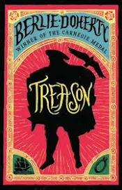
Writing purpose:
Write own adventure based in the Tudor times
Key Writing opportunities:
WALT 1: Hook: Plan paragraphs based around a theme
WALT 2: Identify the features of a narrative
WALT 3: Use descriptive language to describe characters
WALT 4: Use descriptive language to describe settings
WALT 5: Use relative clauses
WALT 6: Use direct speech
WALT 7: Hot write- Opening
WALT 8: Hot write- Build-up
WALT 9: Hot write- Dilemma
WALT 10: Hot write- Resolution
WALT 11: Hot write- Ending
WALT 12: Edit our writing
Key features:
- Opening
- Build-up
- Dilemma
- Resolution
- Ending
- Character descriptions
- Setting descriptions
- Paragraphs around one theme
- Dialogue with punctuation of direct speech
- Past tense
My writing targets:
______________________________________________________________________________________________________________________________________________________________________________________________________
______________________________________________________________________________________________________________________________________________________________________________________________________

