Year 5 | Autumn 2
Text type: Diary Entry
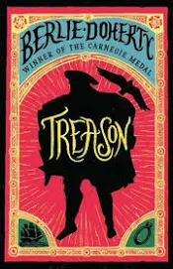
Writing purpose:
Diary entry in the role of the main character
Key Writing opportunities:
WALT 1: Hook: Explore and express a character’s thoughts and feelings on becoming Prince Edward’s page
WALT 2: Identify the features of a diary entry
WALT 3: Understand a character’s thoughts and feelings- Oracy drama opportunity
WALT 4: plan a diary entry using past tense, time adverbials and rhetorical questions
WALT 5: write descriptive sentences
WALT 6: Add extra detail using parenthesis- brackets or dashes
WALT 7: Hot write- Write a diary entry
WALT 8: Edit diary entries
Key features:
- Date
- First person
- Informal greeting
- Informal language
- Past tense
- Introductory paragraph
- Describes events in chronological order
- Paragraphs around one theme
- Thoughts and feelings
- Rhetorical questions
- Time adverbials
- Concluding paragraph
My writing targets:
______________________________________________________________________________________________________________________________________________________________________________________________________
______________________________________________________________________________________________________________________________________________________________________________________________________

