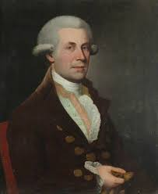
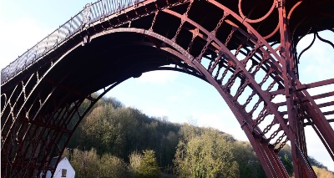
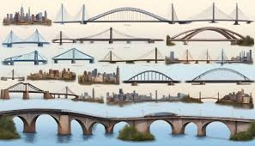
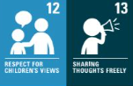
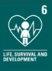
Famous Architect: Thomas Pritchard made the first Iron-bridge.
FOCUS: To understand and experiment with different variations of bridges
Newall Green Primary School Knowledge Organiser
DT Focus: Building Bridges Term: Autumn
Year group: 5
What I should already know:
- What bridges are made out of
- Where you would find a bridge
- The uses of bridges
- A few names of famous bridges e.g. London Bridge
WALT 1 Understand and experiment with beams and pillars Day in the life
Absent Intervention
WALT 2: Understand and experiment with truss bridges
Absent Intervention
WALT 3: Understand and experiment with arch bridges
Absent Intervention
WALT 4: Understand and experiment with suspension bridges
Day in the life
Absent Intervention
WALT 5: Design, make and evaluate a successful bridge
Absent Intervention
Key Vocabulary:
Truss 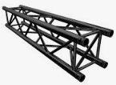– a framework which supports a roof, bridge, or other structure.
Structure 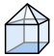 – building or other object constructed from several parts.
Pillar 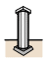 - a tall vertical structure of stone, wood, or metal, used as a support for a building, or as an ornament or monument.
Beam  - a long, sturdy piece of squared timber or metal used to support the roof or floor of a building.
Span 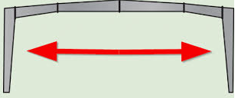- the full extent of something from end to end; the amount of space that something covers.
Prototype – the first version of something before it gets developed.
Construction  - the action of building something, typically a large structure.
Design criteria  – the process of developing a design.

