Year 5 | Autumn 2
Text type: Poetry
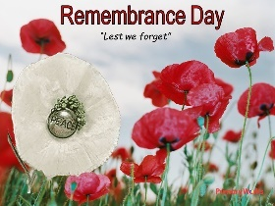
Writing purpose:
Remembrance Day performance poetry.
Key Writing opportunities:
WALT 1: Hook - perform ‘In Flanders fields’ by John McCrae (DITLF).
WALT 2: Identify the features of a poem.
WALT 3: Use similes, metaphors and personification to create powerful imagery
WALT 4: Write a Remembrance Day poem
WALT 5: Perform our Remembrance Day poem (DITLF)
Key features:
- Stanzas
- Rhythm
- Repeating patterns
- Similes
- Metaphors
- Alliteration
- Personification
- Powerful imagery
- Repetition
- Emotive language
- Rhyme (optional)
My writing targets:
______________________________________________________________________________________________________________________________________________________________________________________________________
______________________________________________________________________________________________________________________________________________________________________________________________________

